Tour ID: 265939  
Tour Name: Arctic Canada and Greenland Expedition—Circumnavigating Baffin Bay

Tour destinations: ['Reykjavik', 'Nuuk', 'Qikiqtarjuaq', 'Lancaster Sound', 'Devon Island', 'Thule', 'Disko Bay']

Tour destinations images:

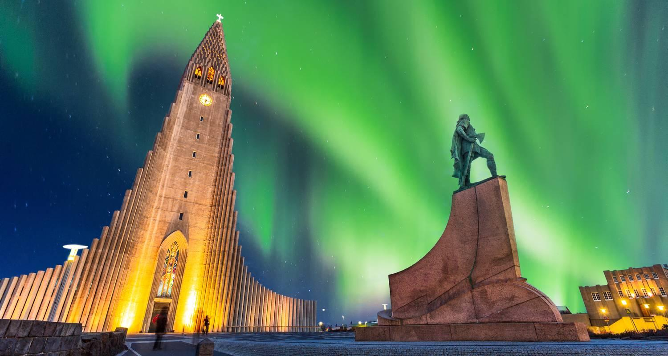

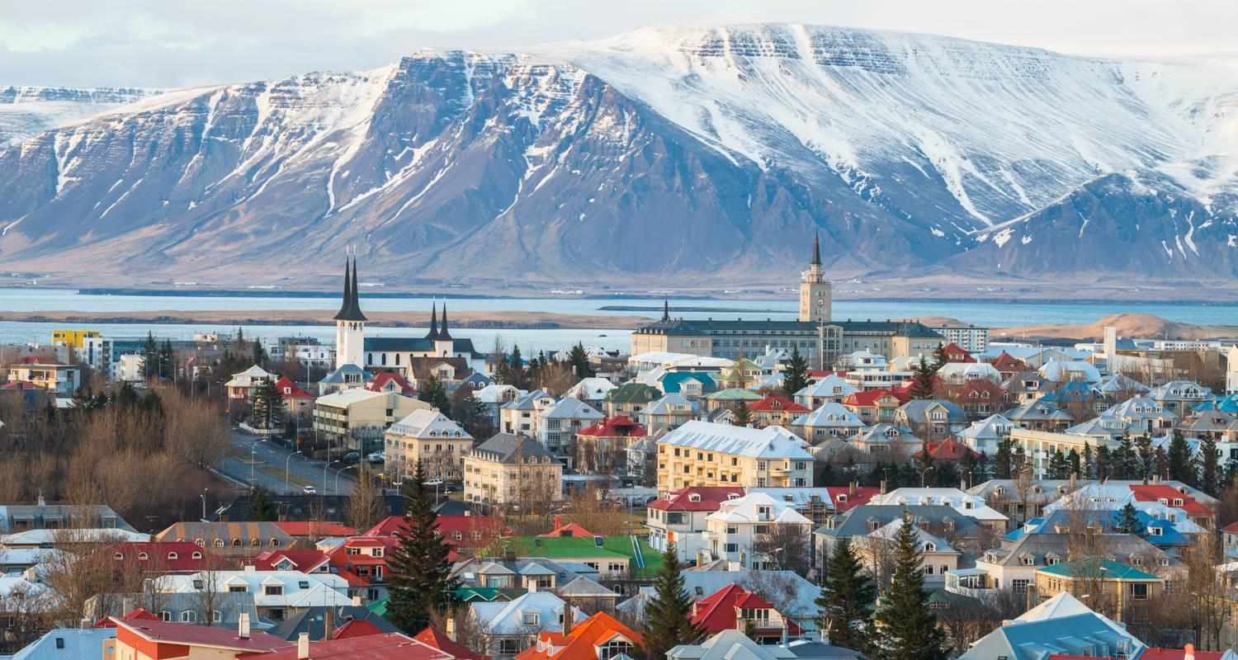

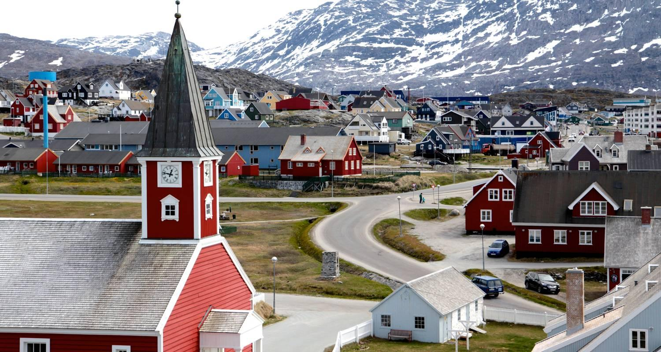

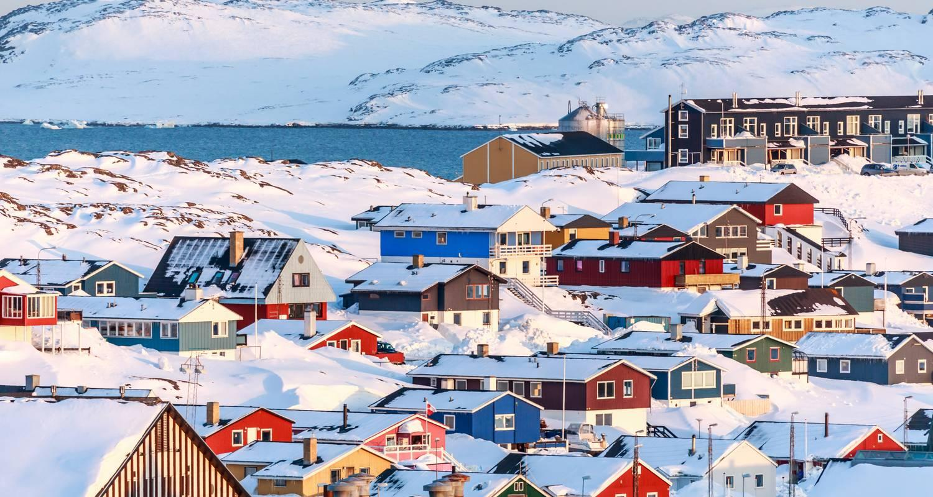

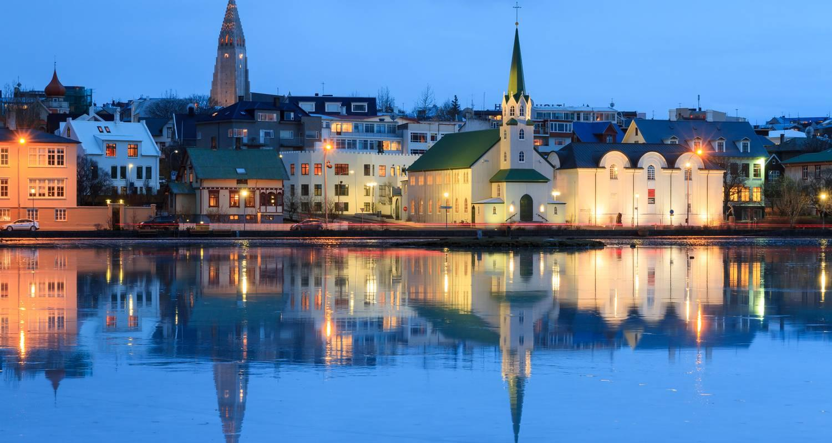

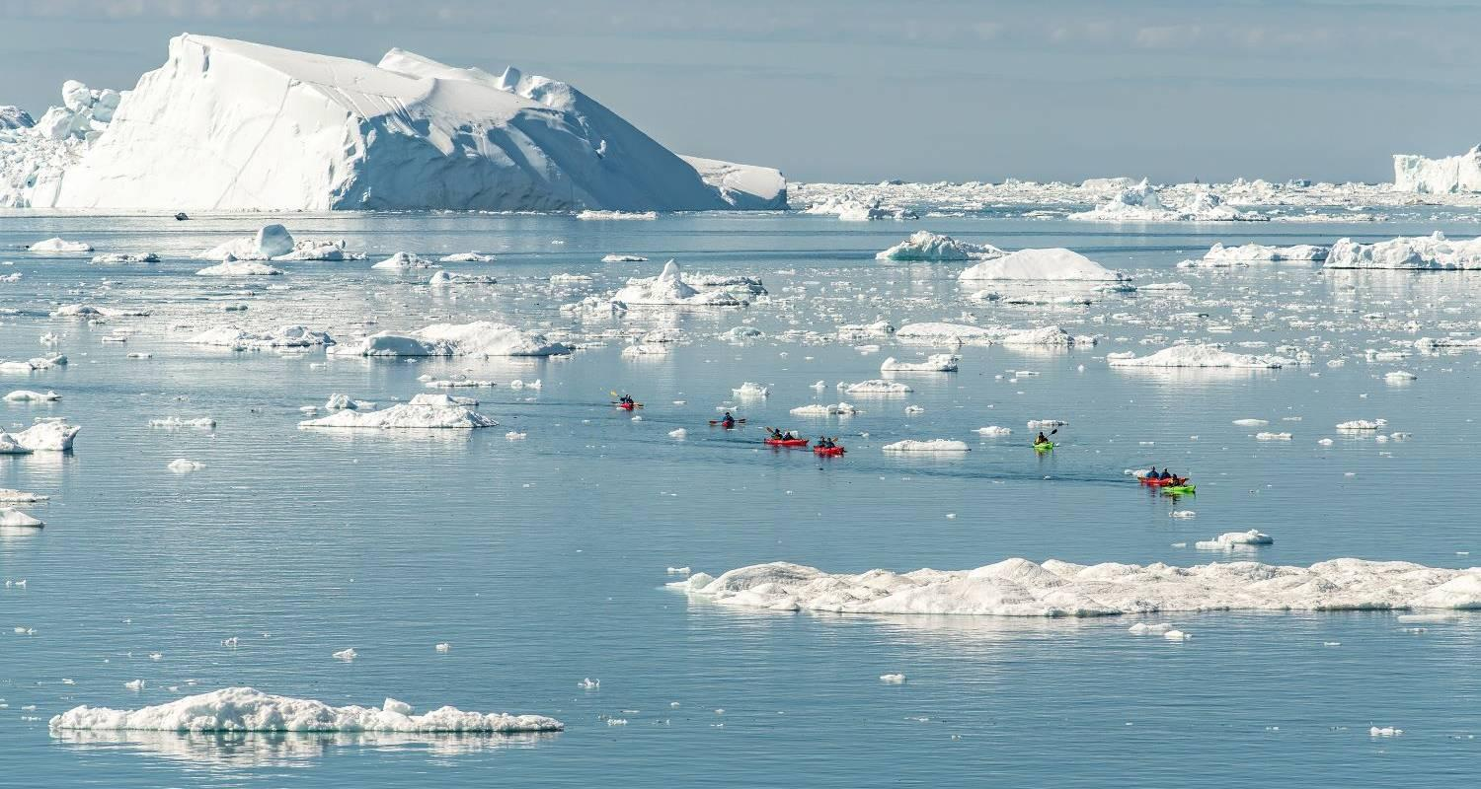

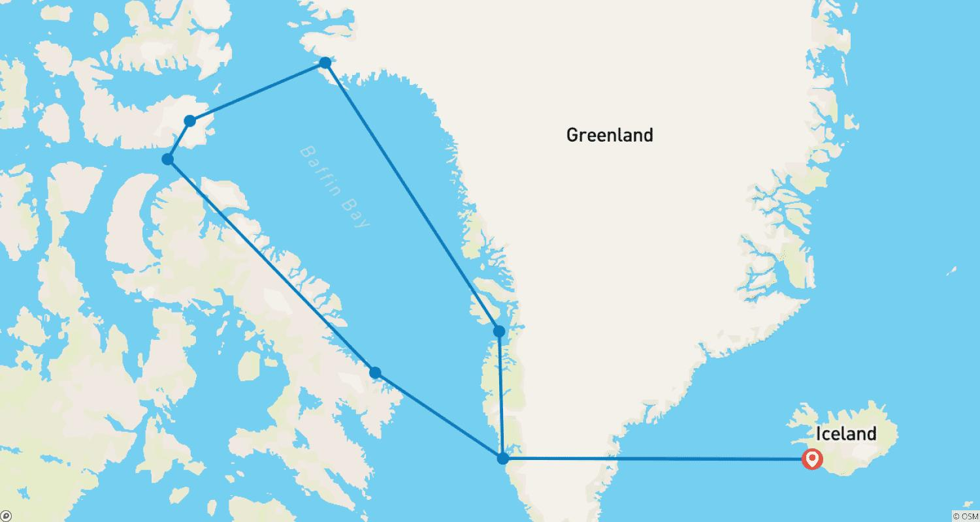

Tour ID: 266102  
Tour Name: Iceland Explorer Self Drive - Summer

Tour destinations: ['Reykjavik', 'Vik', 'Hofn', 'Egilsstadir', 'Myvatn', 'Siglufjordur', 'Borgarnes']

Tour destinations images:

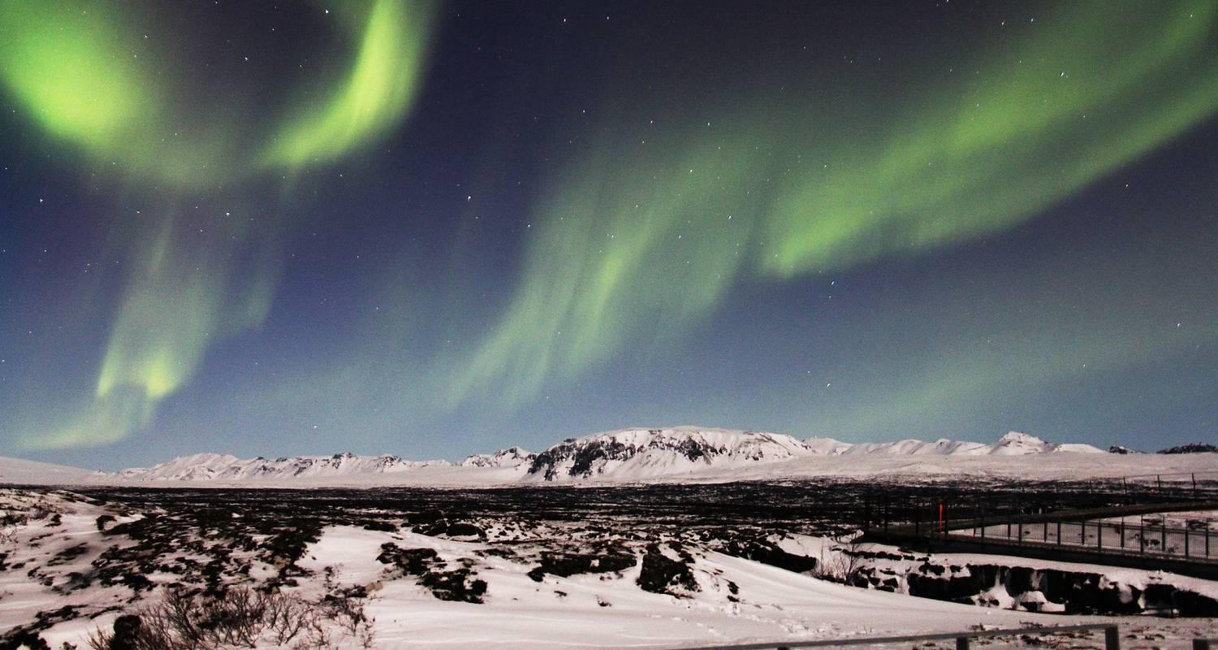

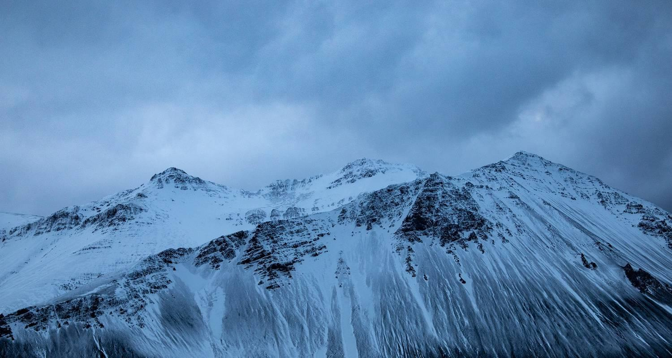

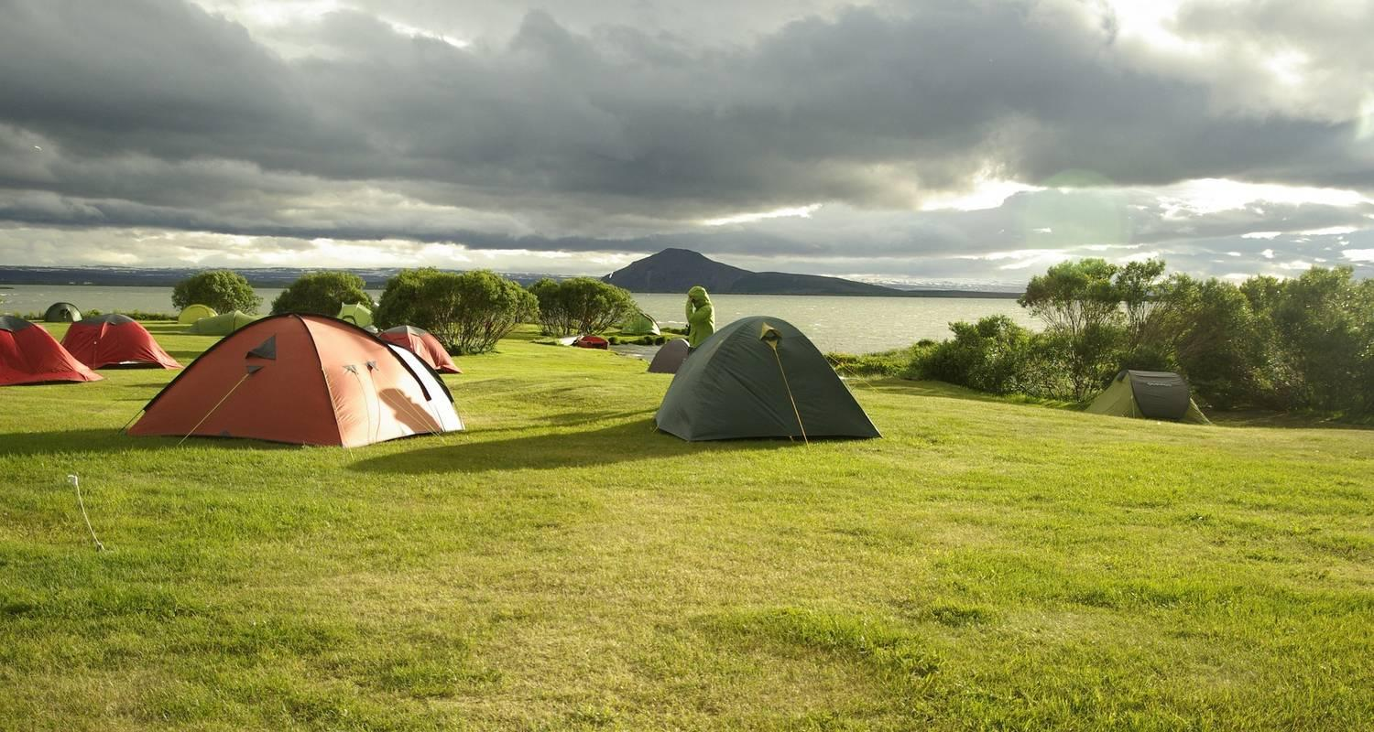

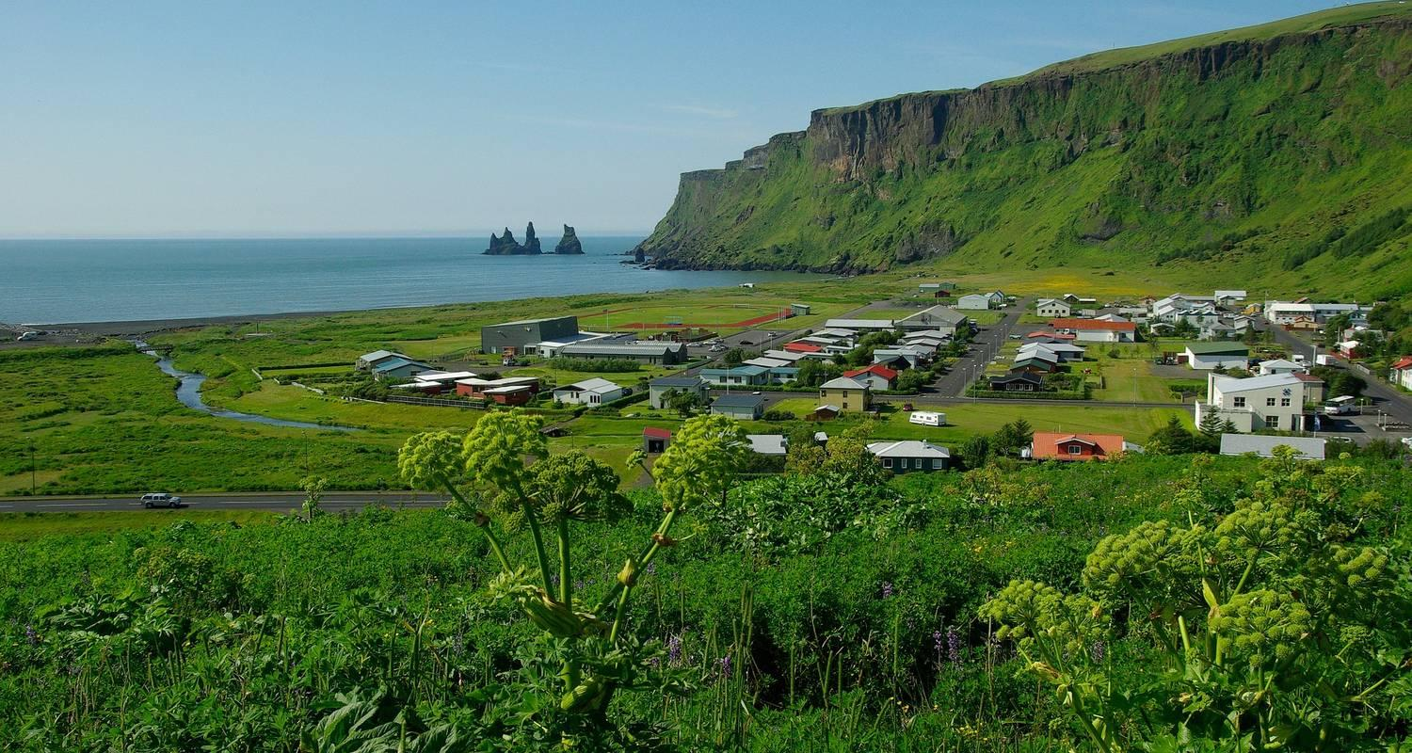

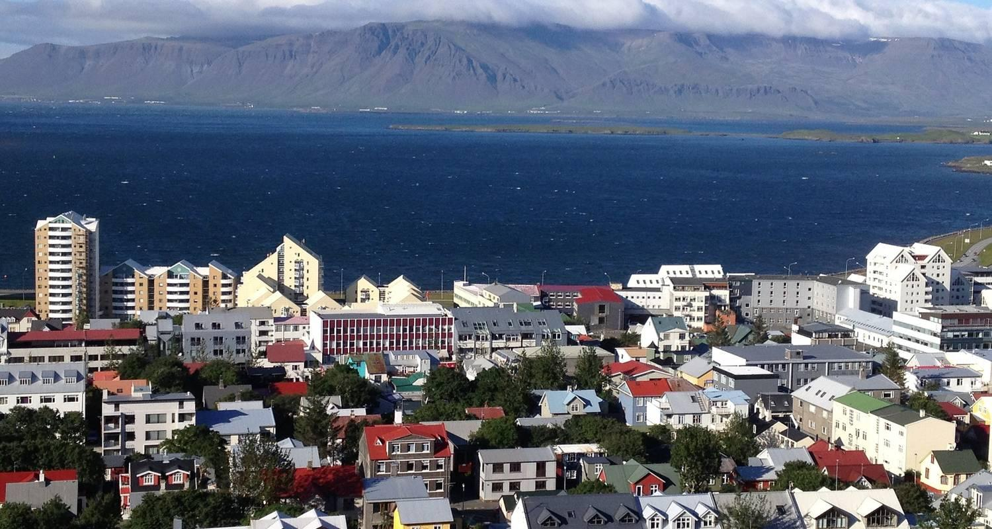

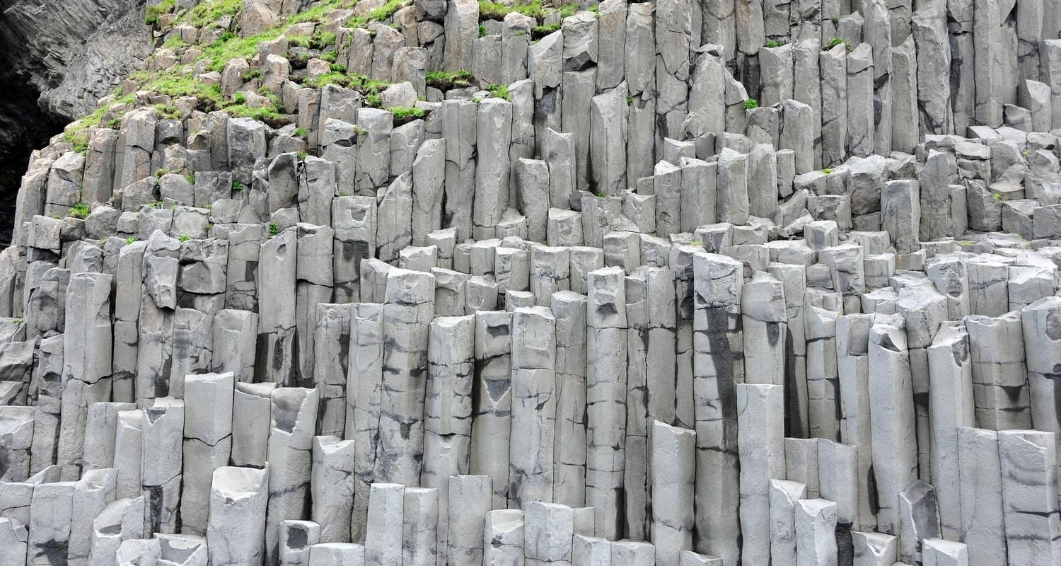

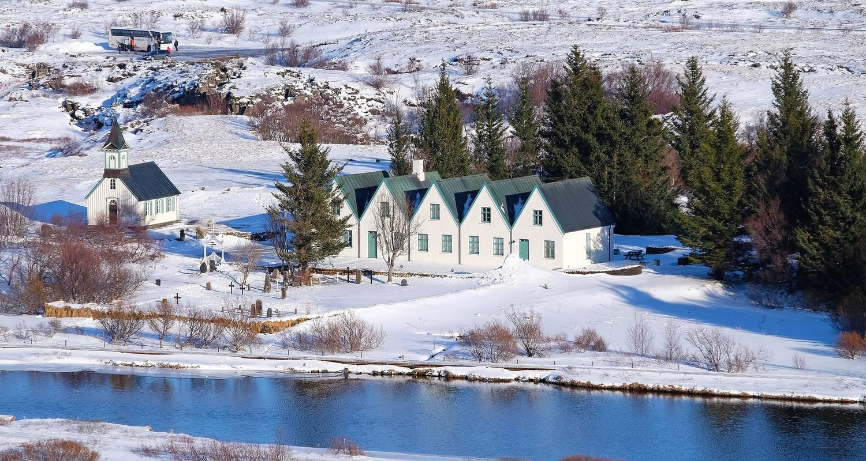

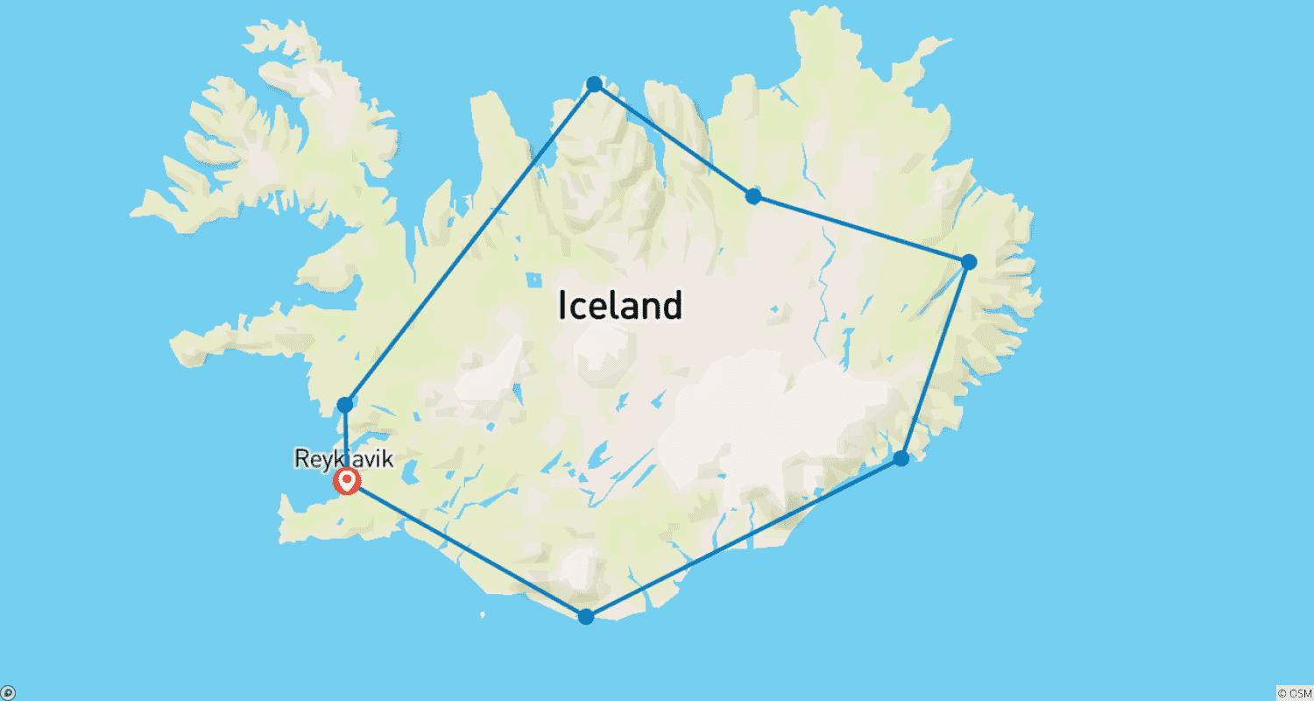

Tour ID: 266269  
Tour Name: Iceland in 4 Days

Tour destinations: ['Reykjavik']

Tour destinations images:

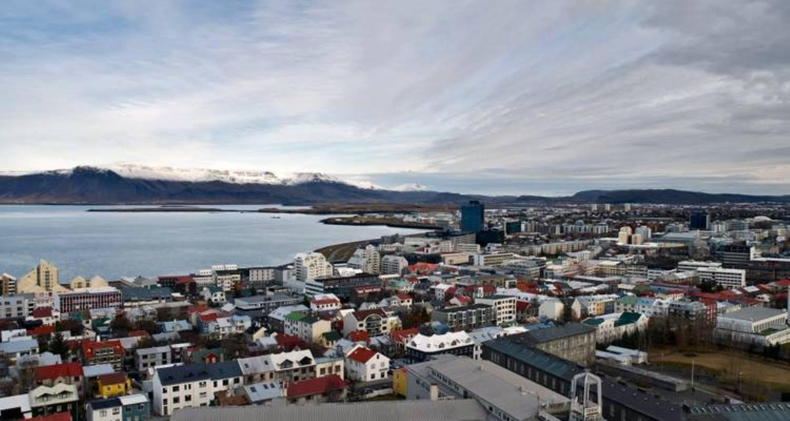

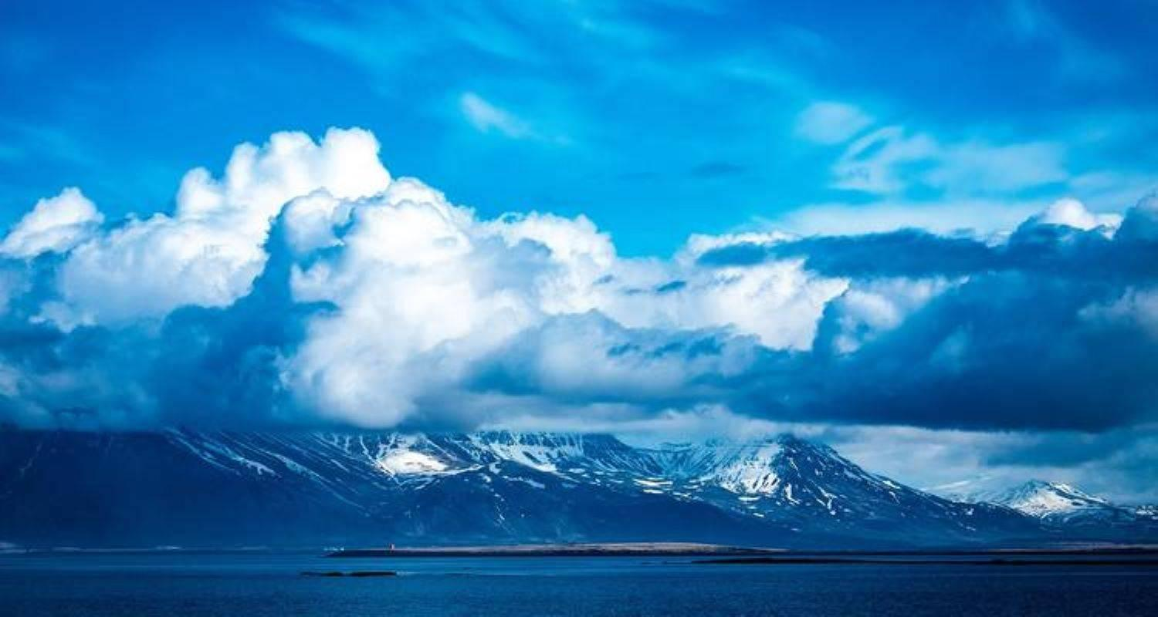

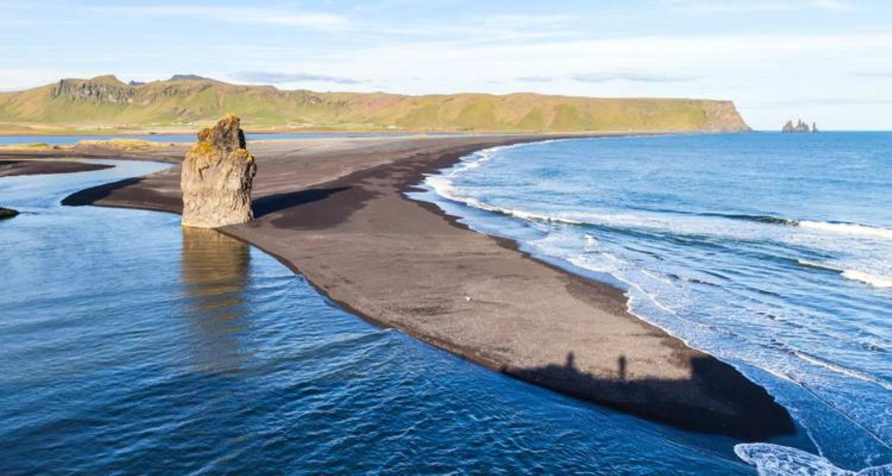

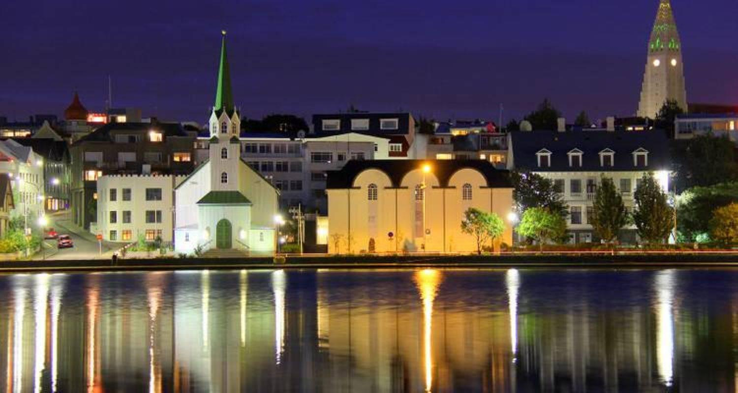

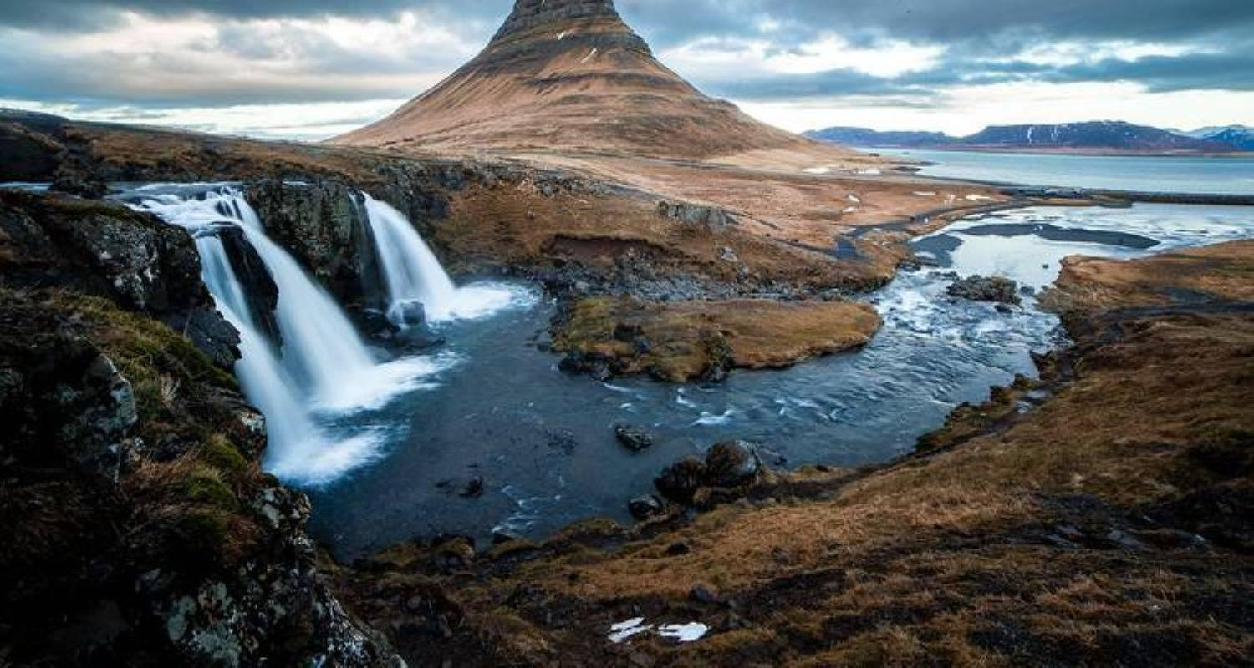

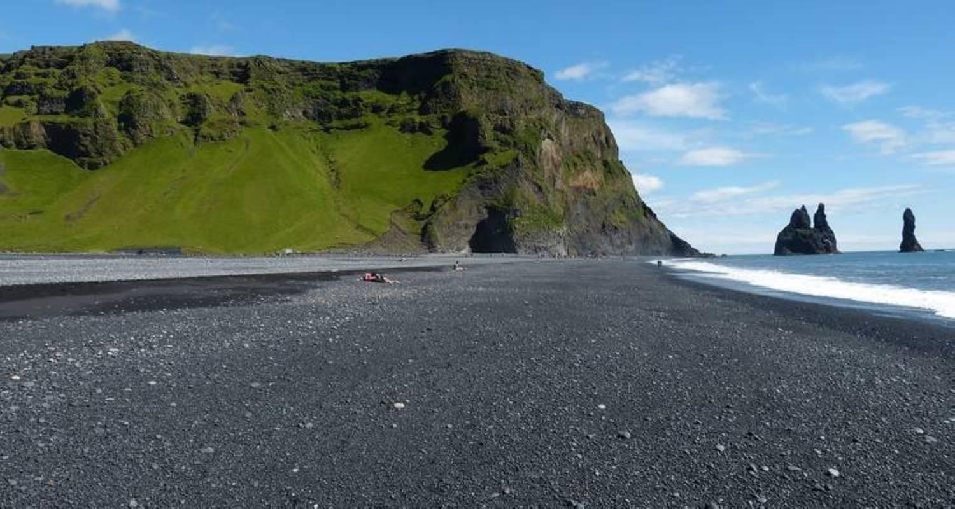

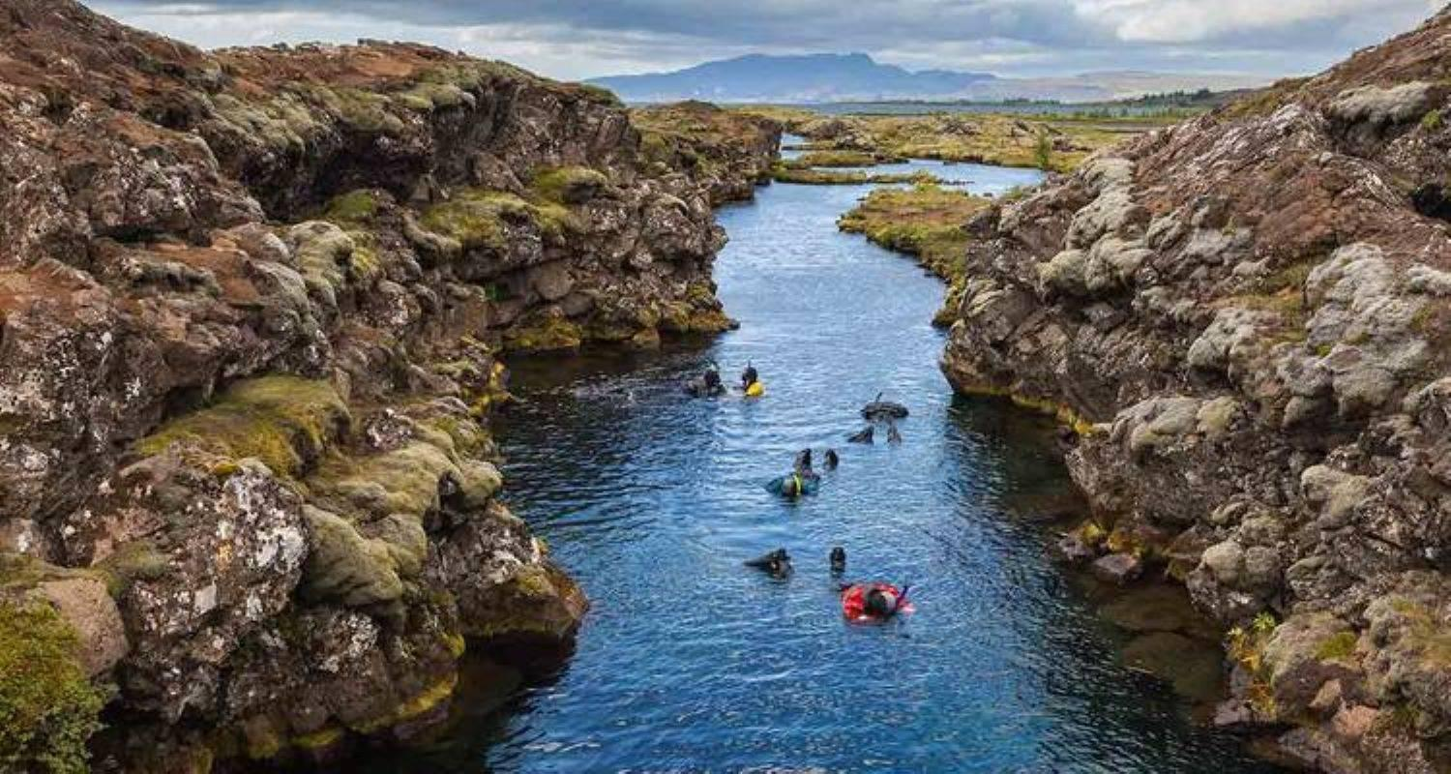

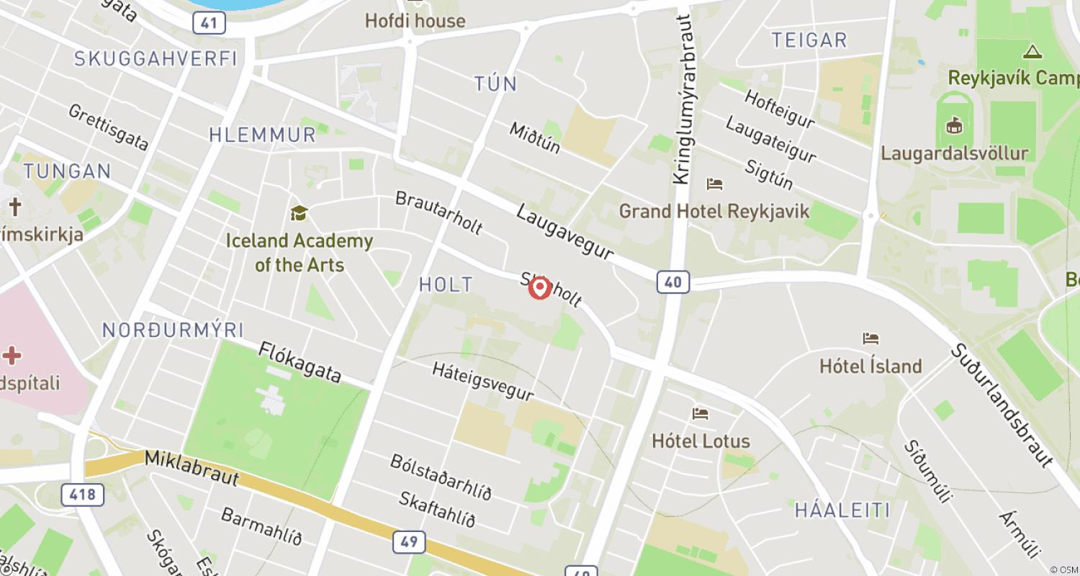

Tour ID: 266690  
Tour Name: Circumnavigating Iceland & the Fjords of East Greenland

Tour destinations: ['Reykjavik', 'Stykkisholmur', 'Snæfellsnes', 'Patreksfjordur', 'Akureyri', 'Grimsey', 'Husavik', 'Bakkagerdi', 'Heimaey Island', 'Ittoqqortoormiit']

Tour destinations images:

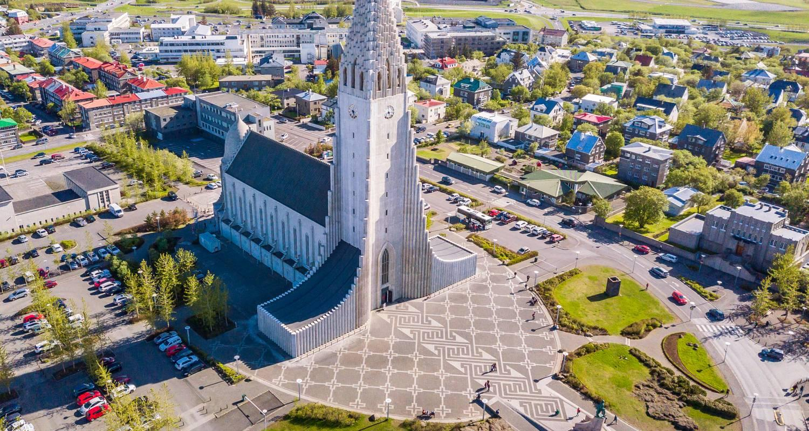

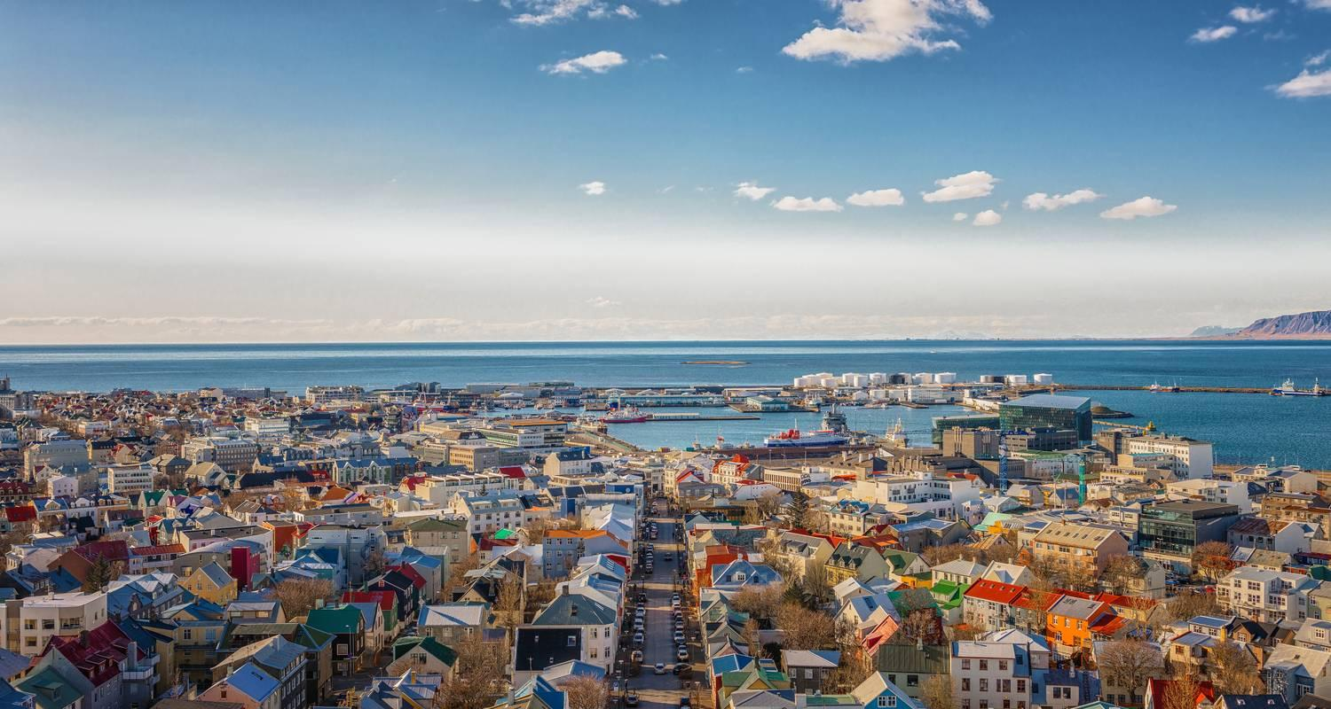



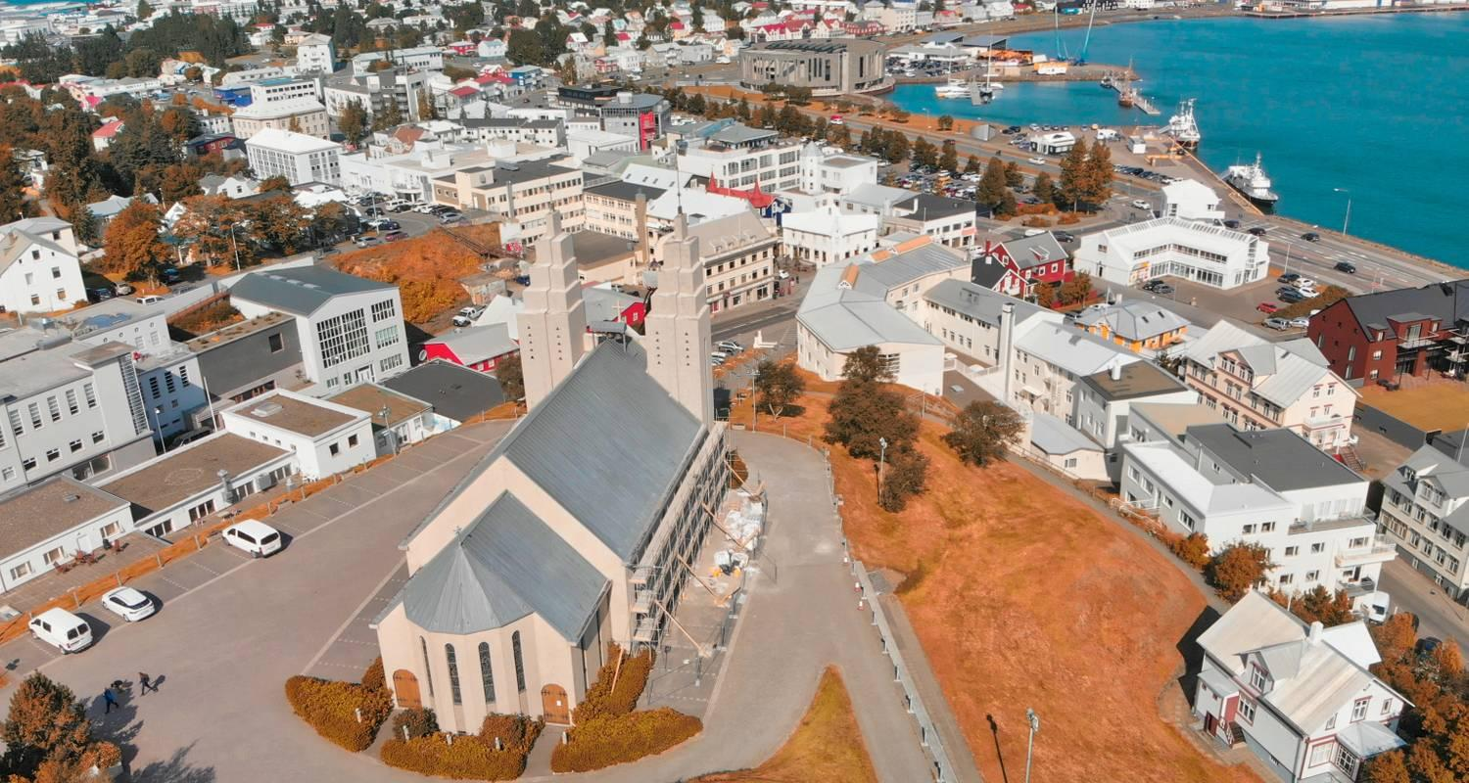

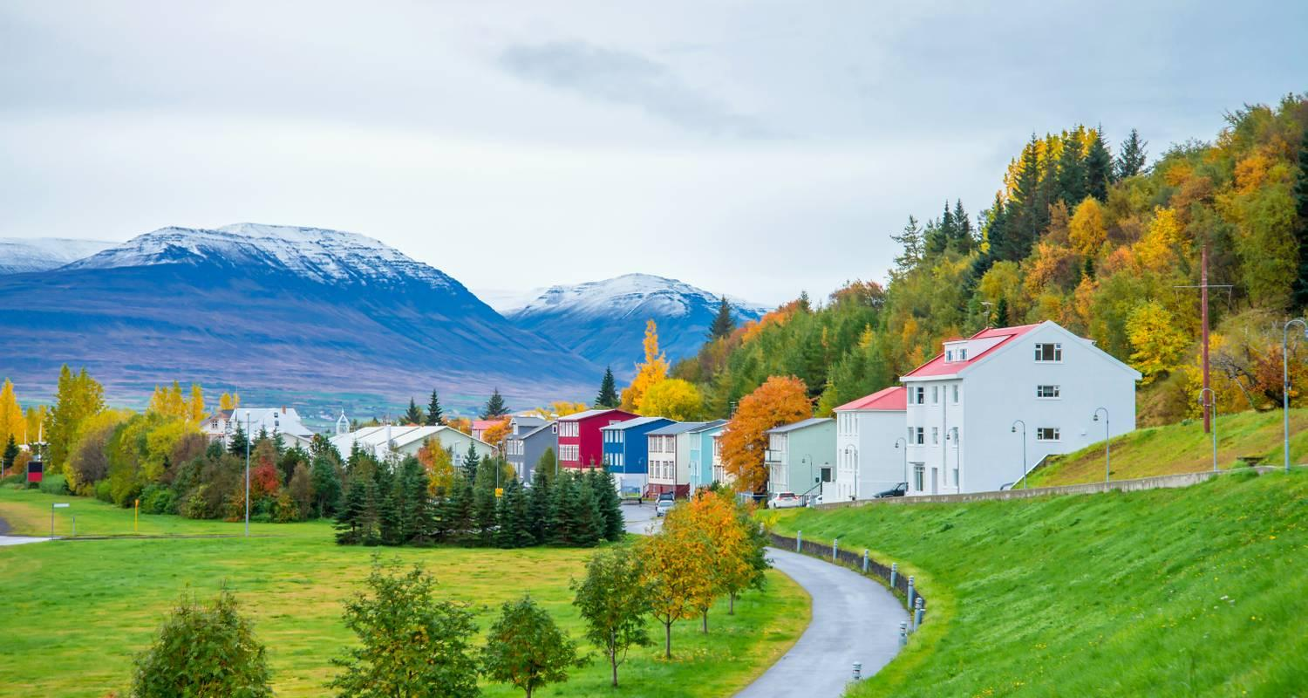

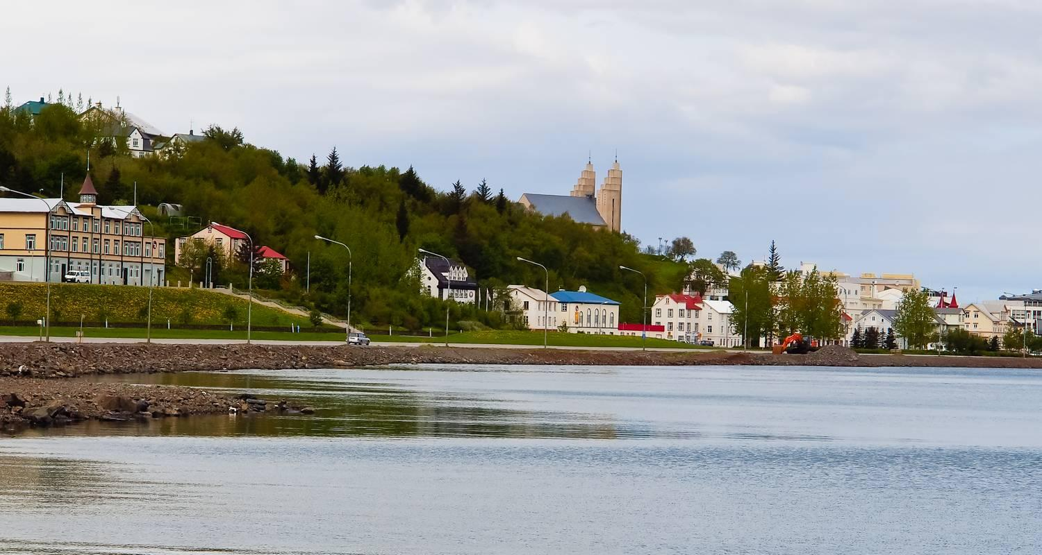

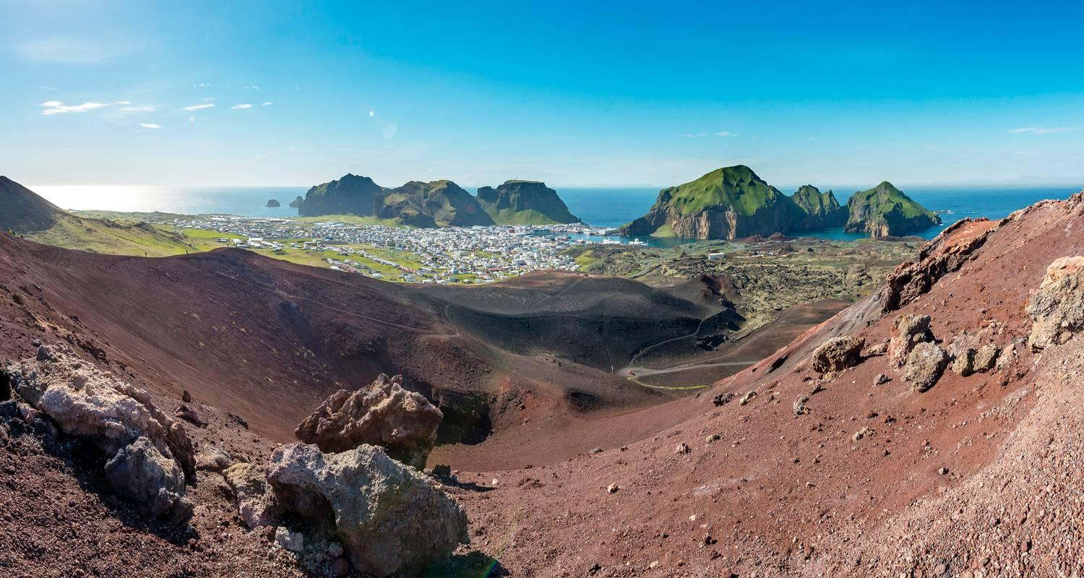

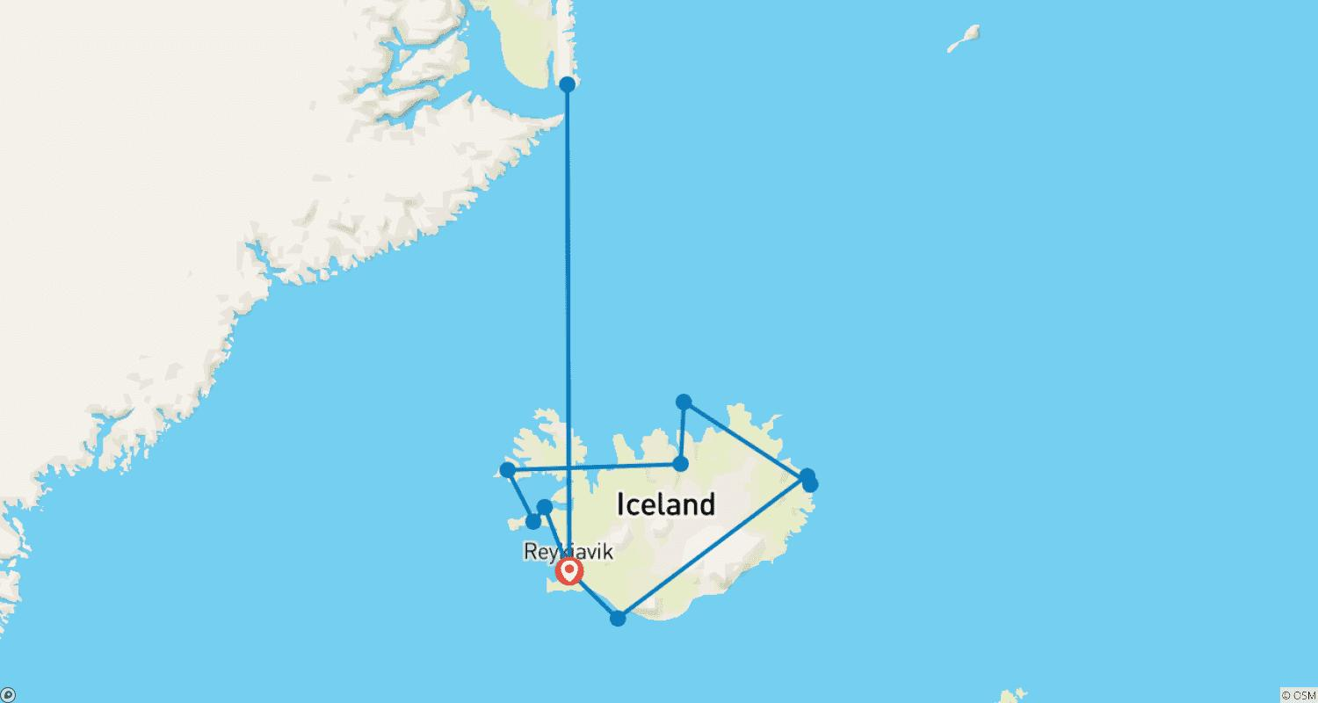

Tour ID: 267838  
Tour Name: Scenic Iceland and the Northern Lights (Classic, 7 Days)

Tour destinations: ['Reykjavik', 'Vik', 'Keflavik', 'Fludir', 'Thingvellir National Park', 'Borgarnes', 'Húsafell']

Tour destinations images:









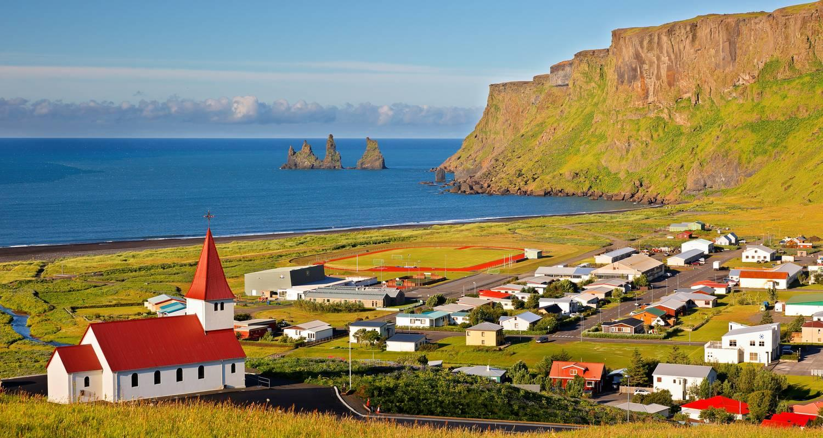

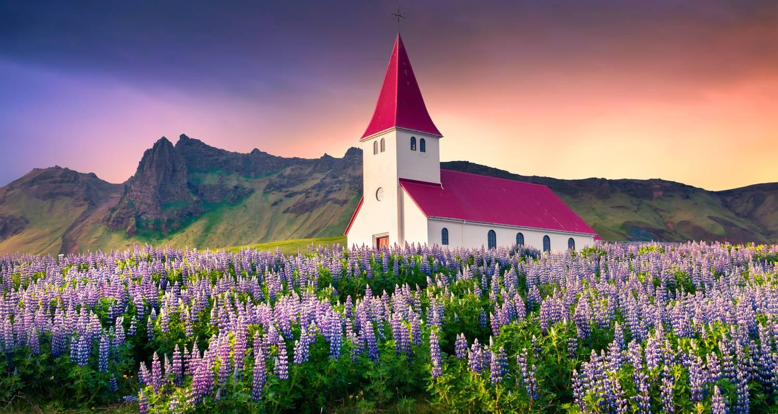

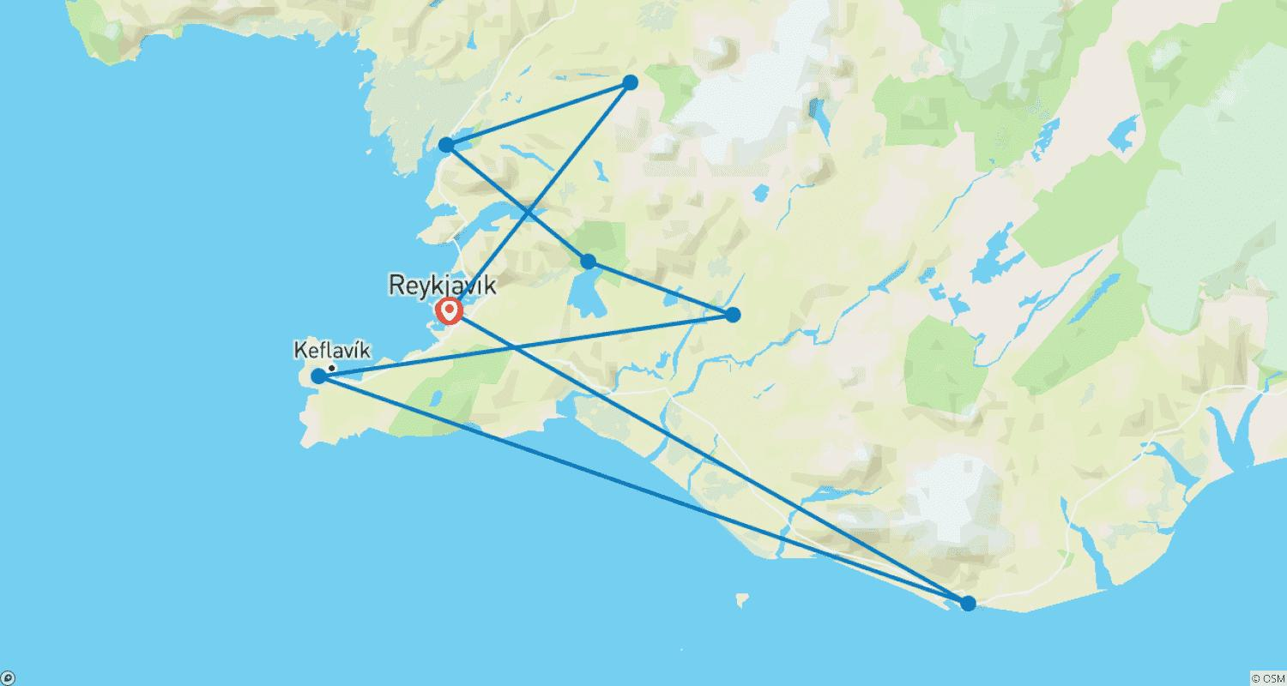

Tour ID: 268186  
Tour Name: Greenland, Labrador and Newfoundland—Encounters at the Edge

Tour destinations: ['Reykjavik', 'Nuuk', 'Qassiarsuk', 'Qaqortoq', 'Torngat Mountains National Park', 'Hebron', 'Battle Harbour', 'Red Bay', 'Bonavista', 'Saint John']

Tour destinations images:













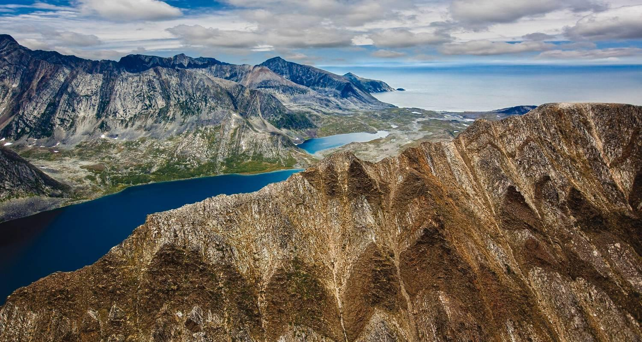

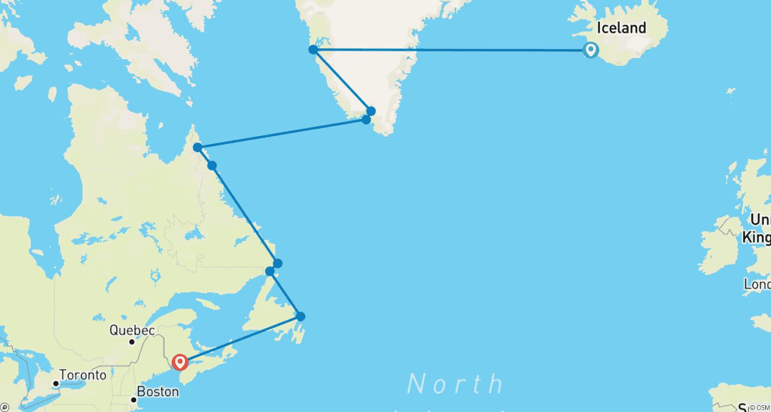

Tour ID: 268765  
Tour Name: Iceland's Magical Northern Lights (2025)

Tour destinations: ['Reykjavik', 'Vik', 'Reynisfjara', 'Jokulsarlon']

Tour destinations images:

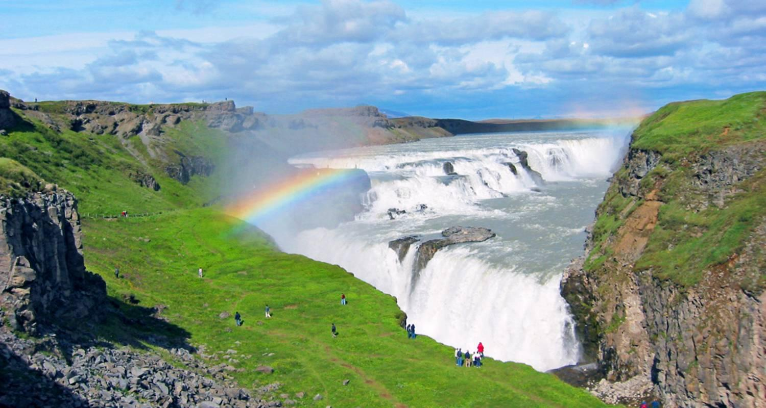

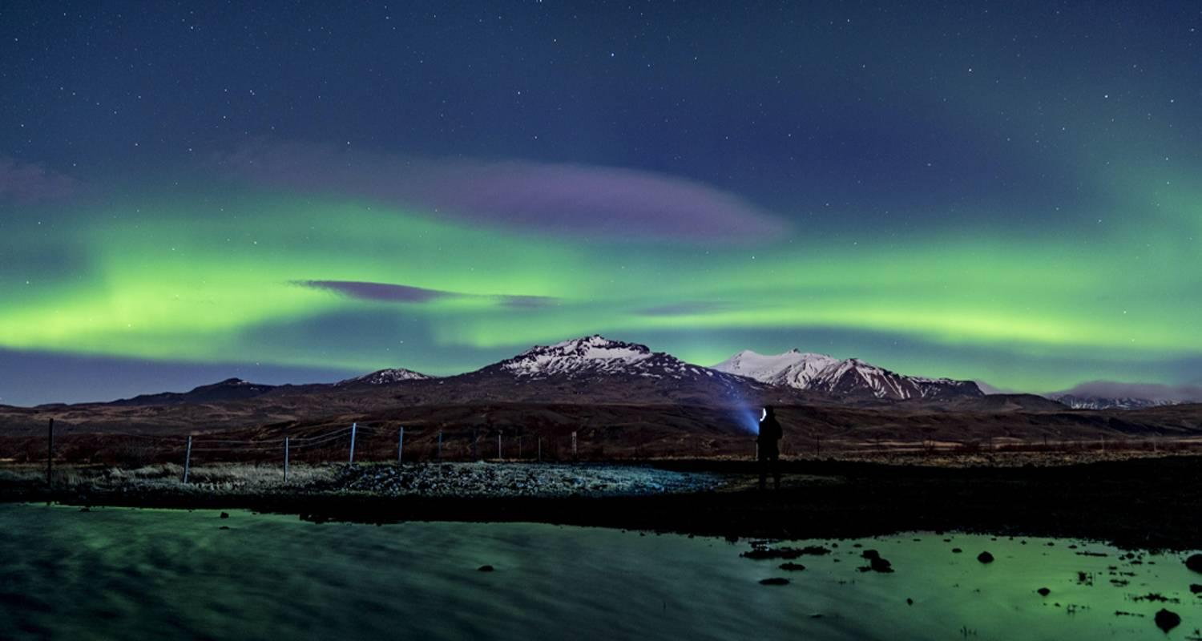

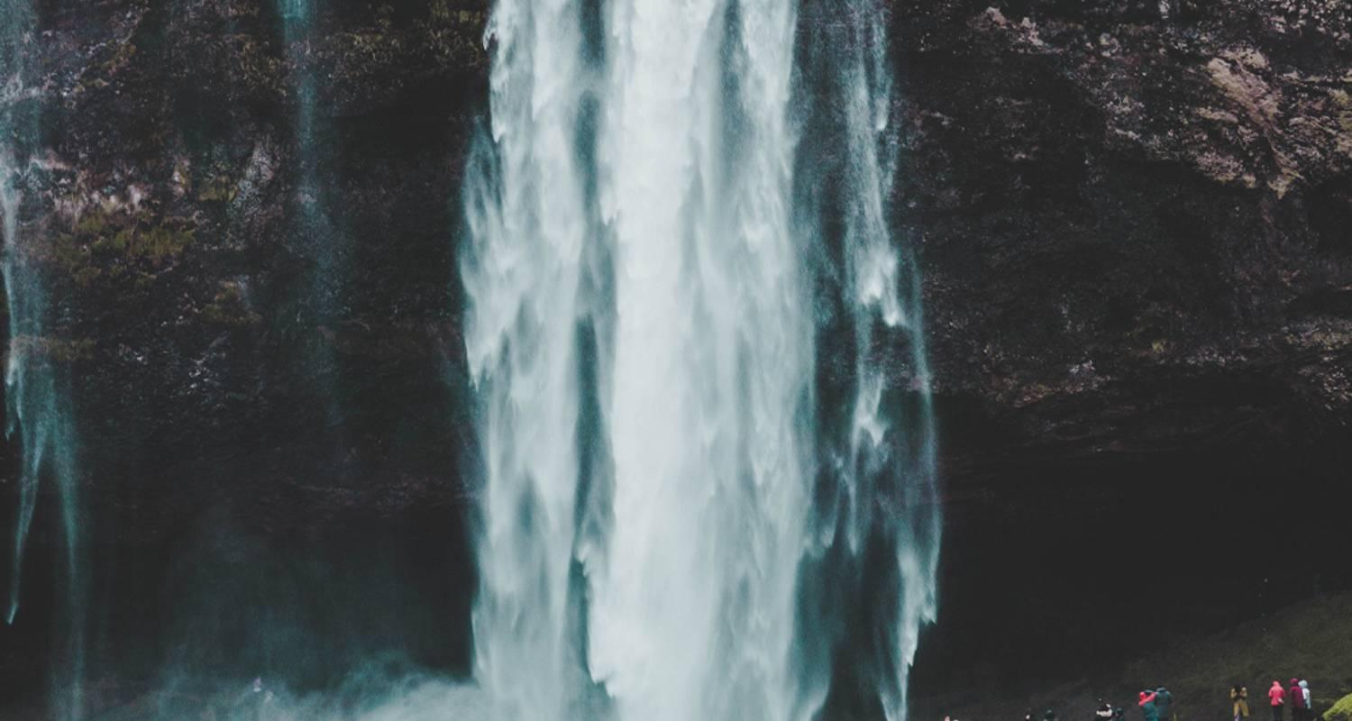

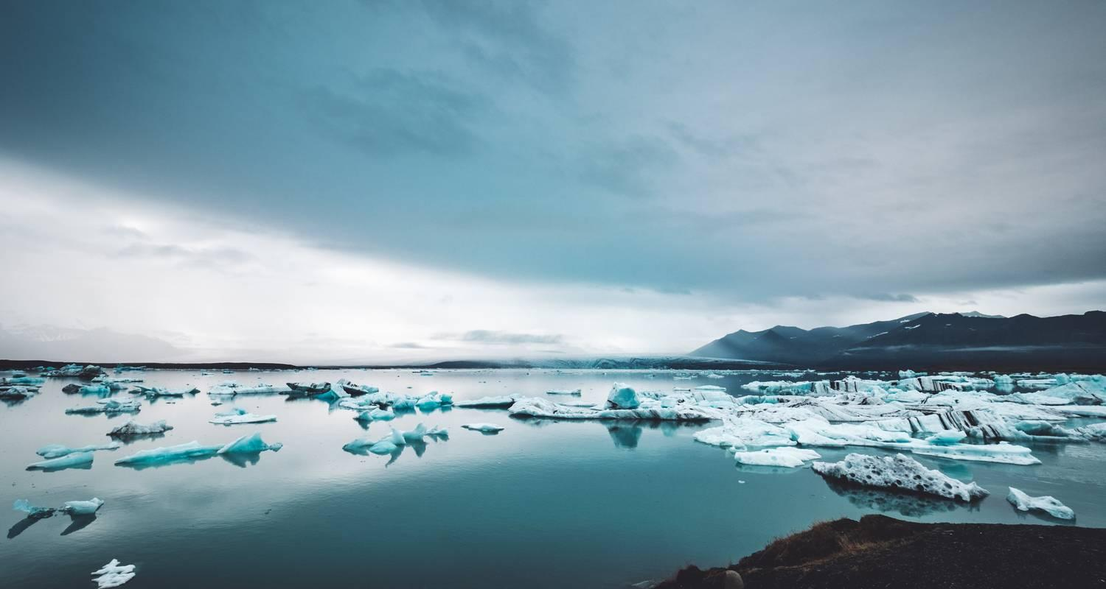

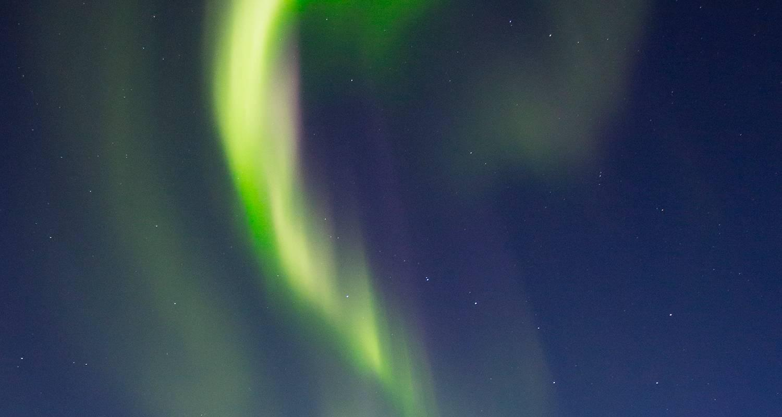

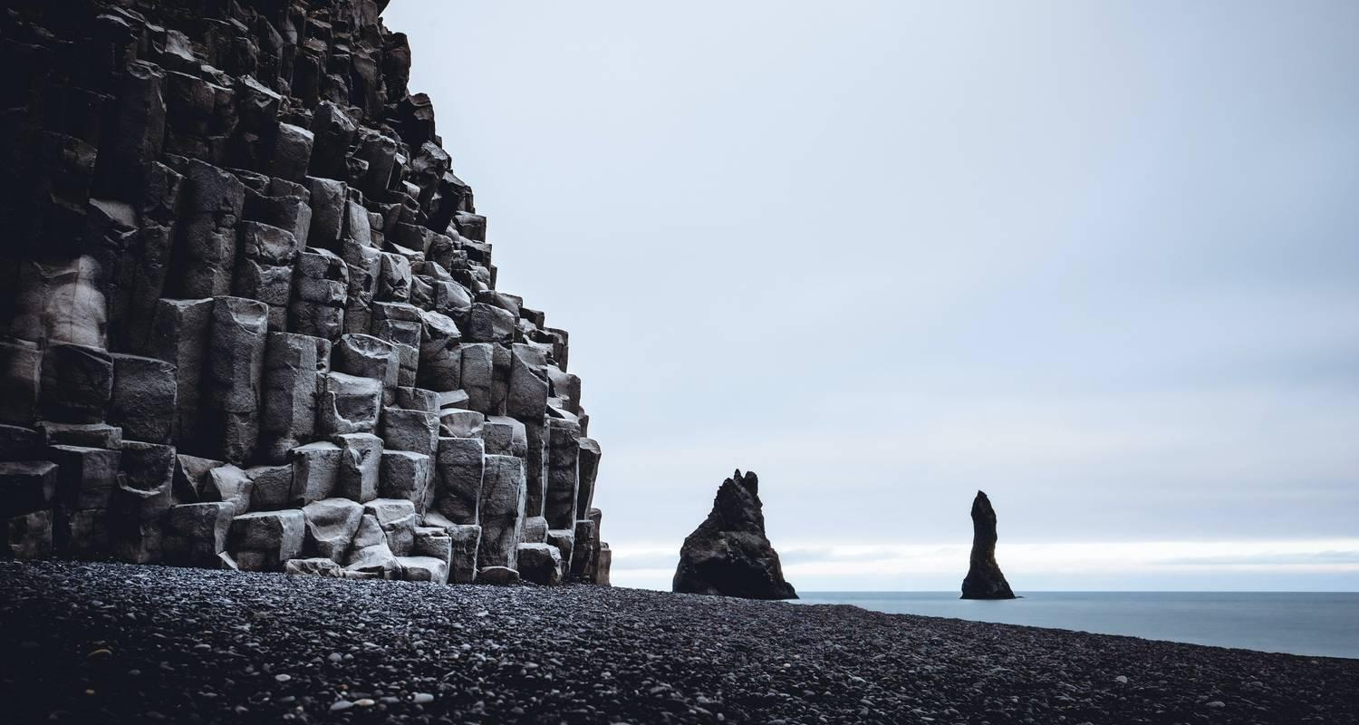



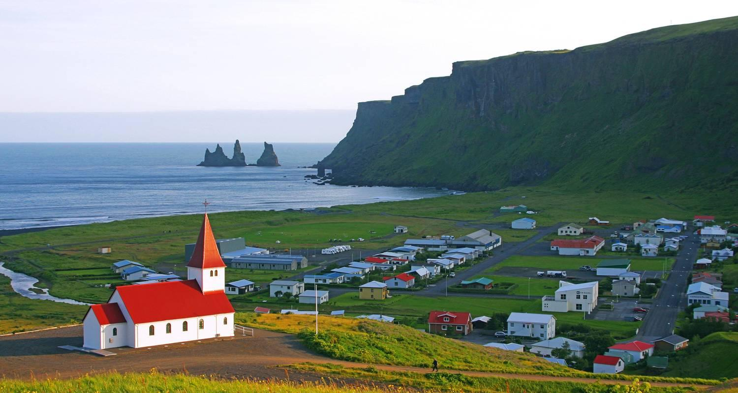

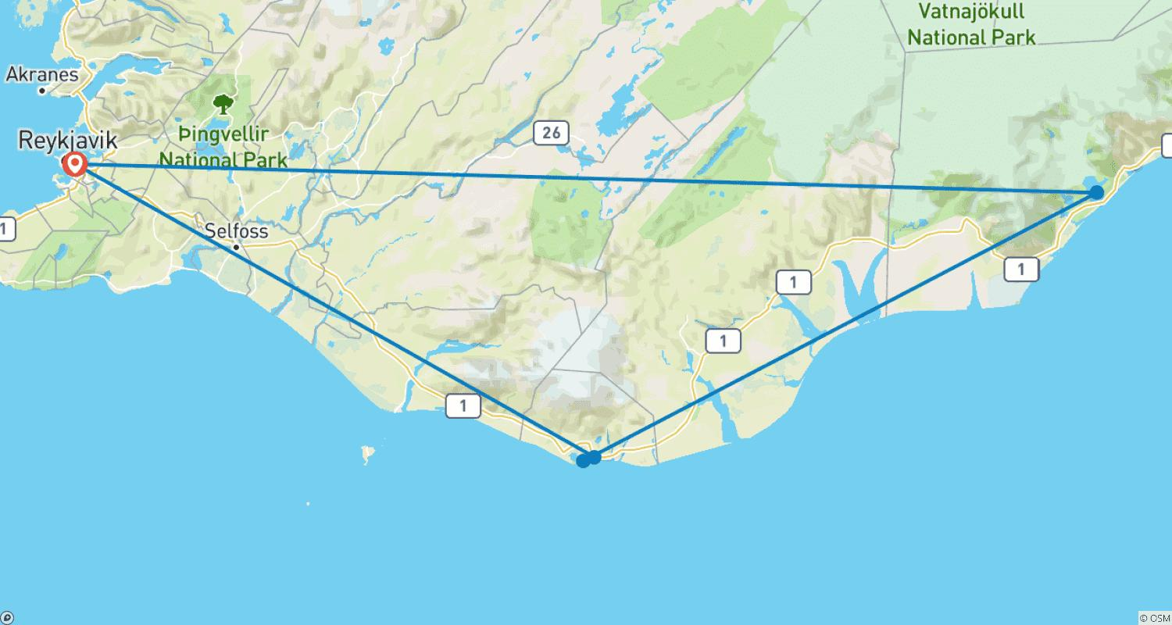

Tour ID: 269815  
Tour Name: Iceland: Land of Fire & Ice (2025)

Tour destinations: ['Reykjavik', 'Gullfoss', 'Geysir', 'Thingvellir National Park', 'Akranes', 'Reykholt', 'Stykkisholmur', 'Vik', 'Reynisfjara', 'Jokulsarlon']

Tour destinations images:

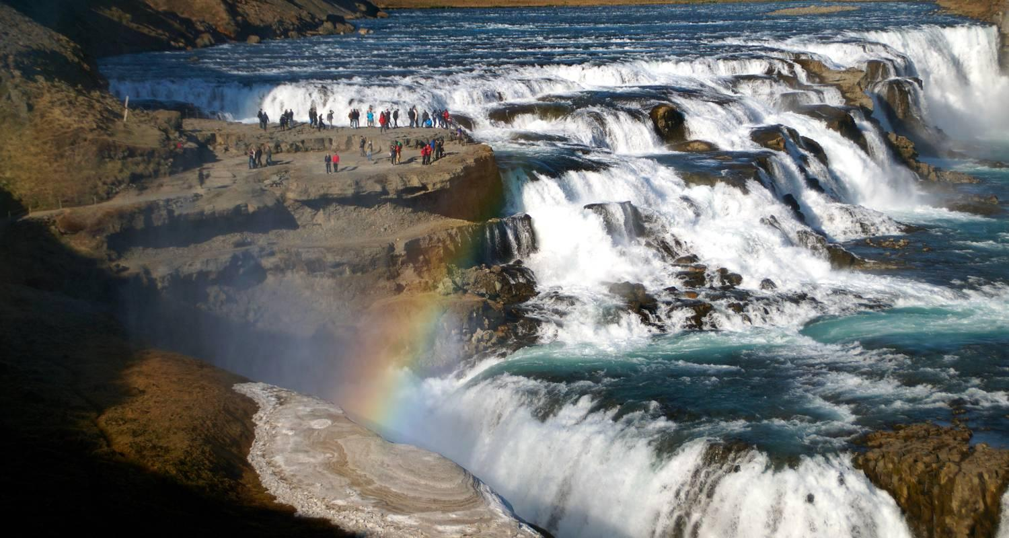

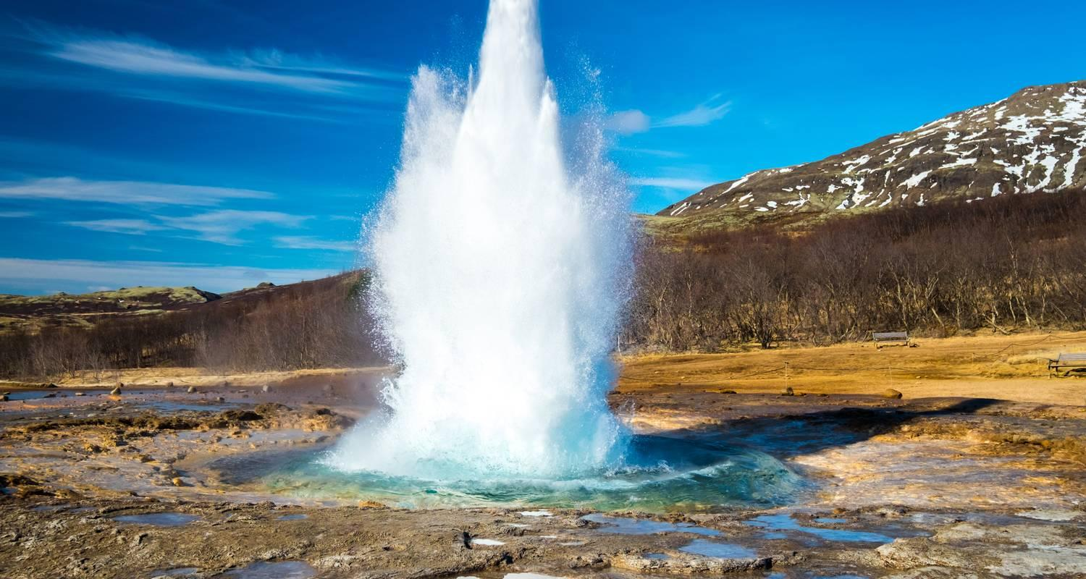

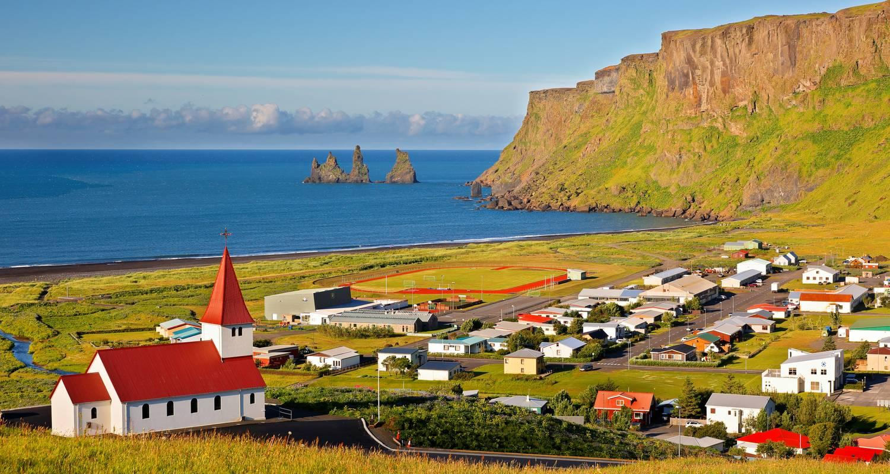

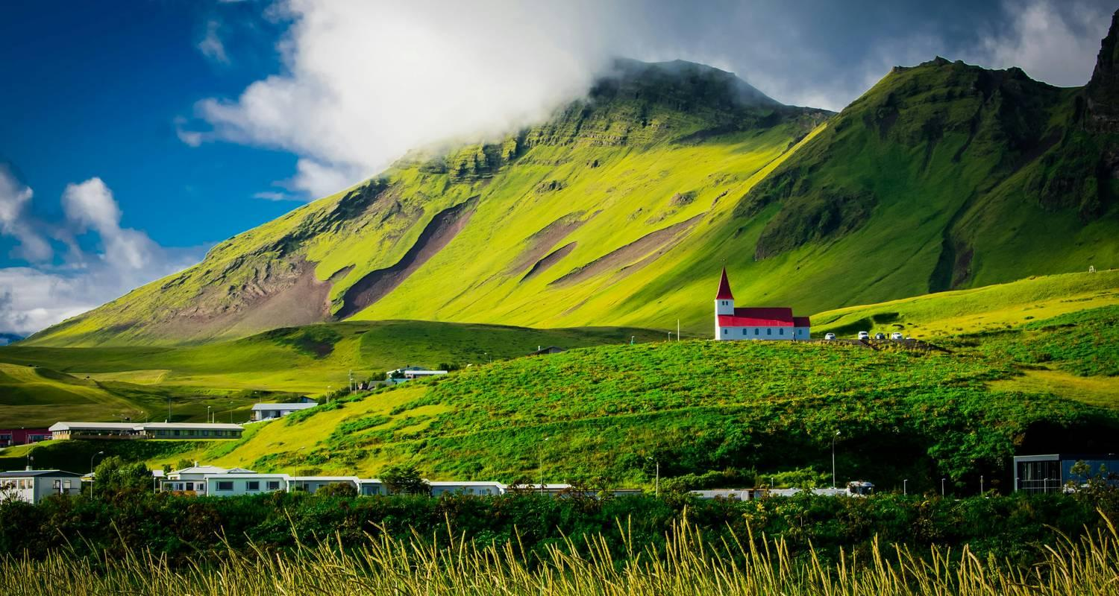

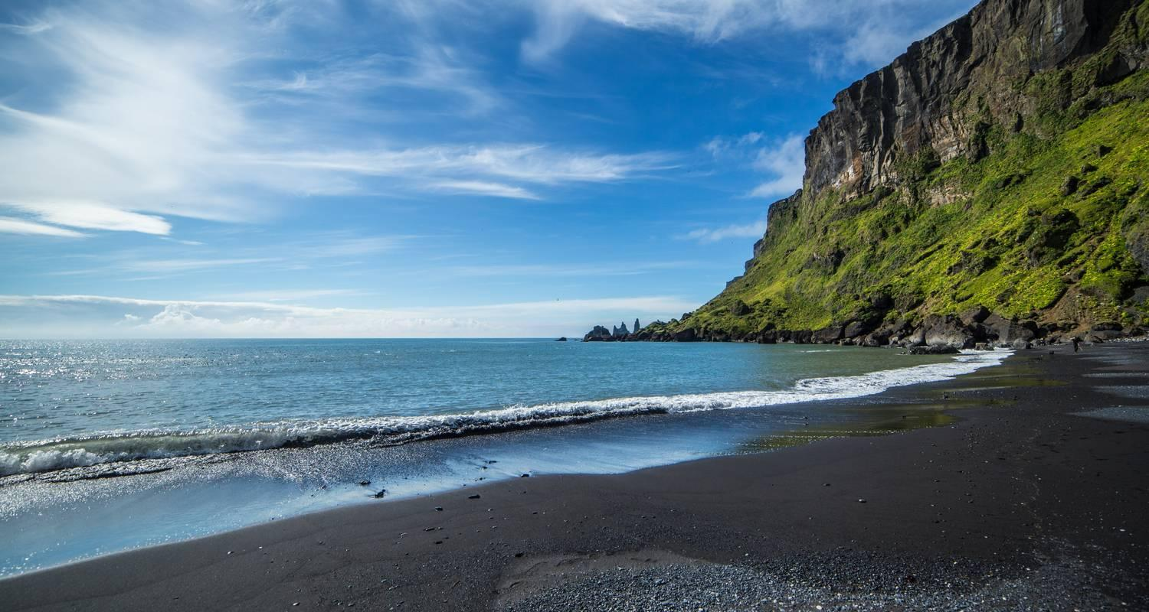

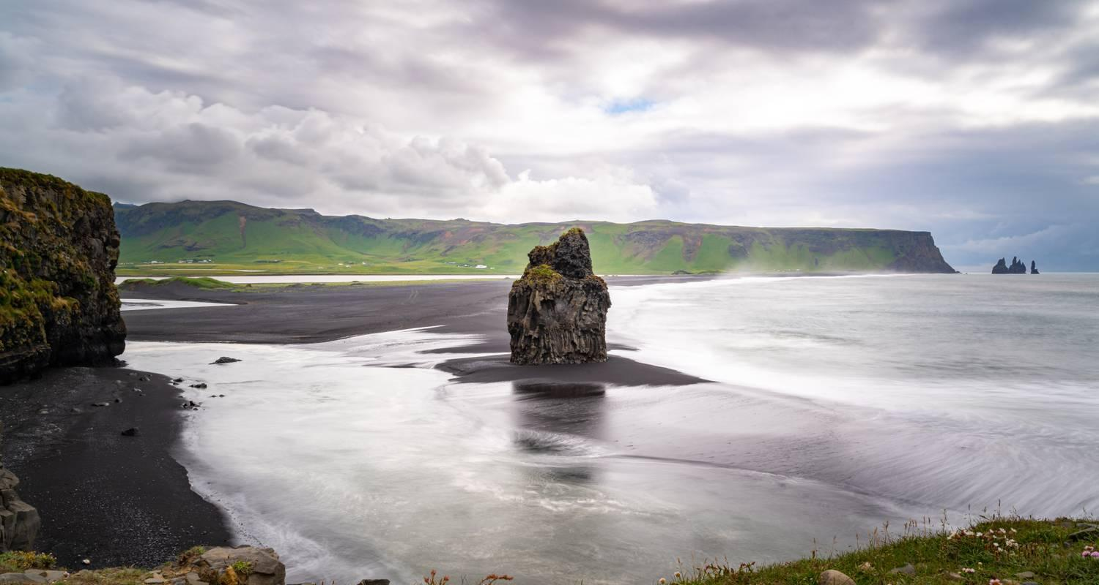

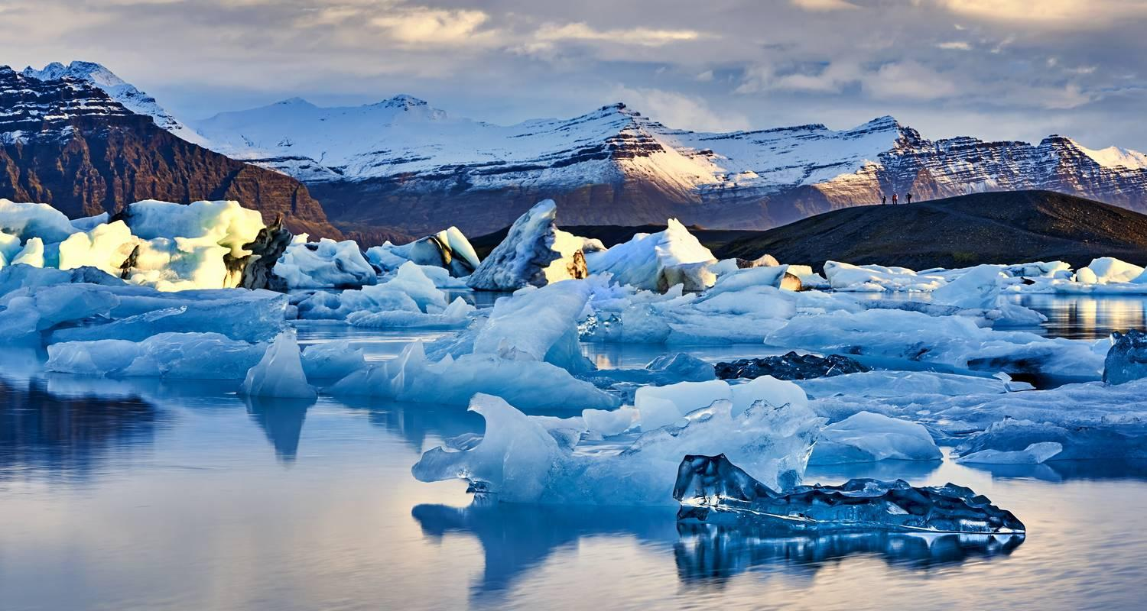

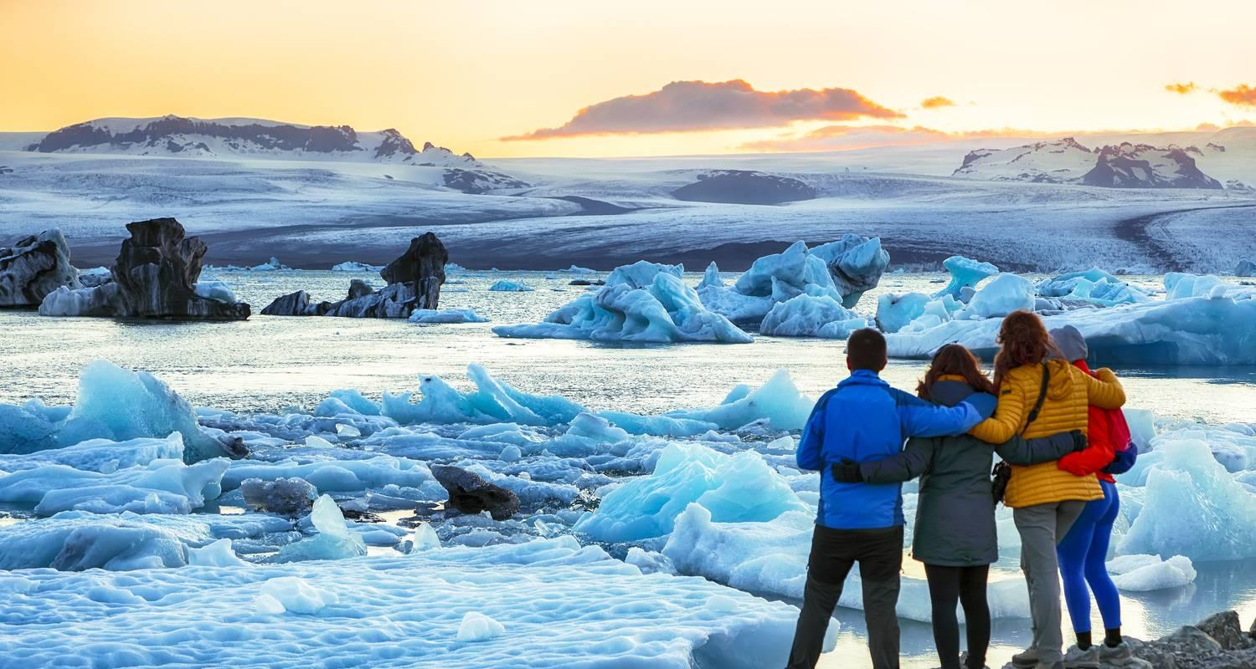

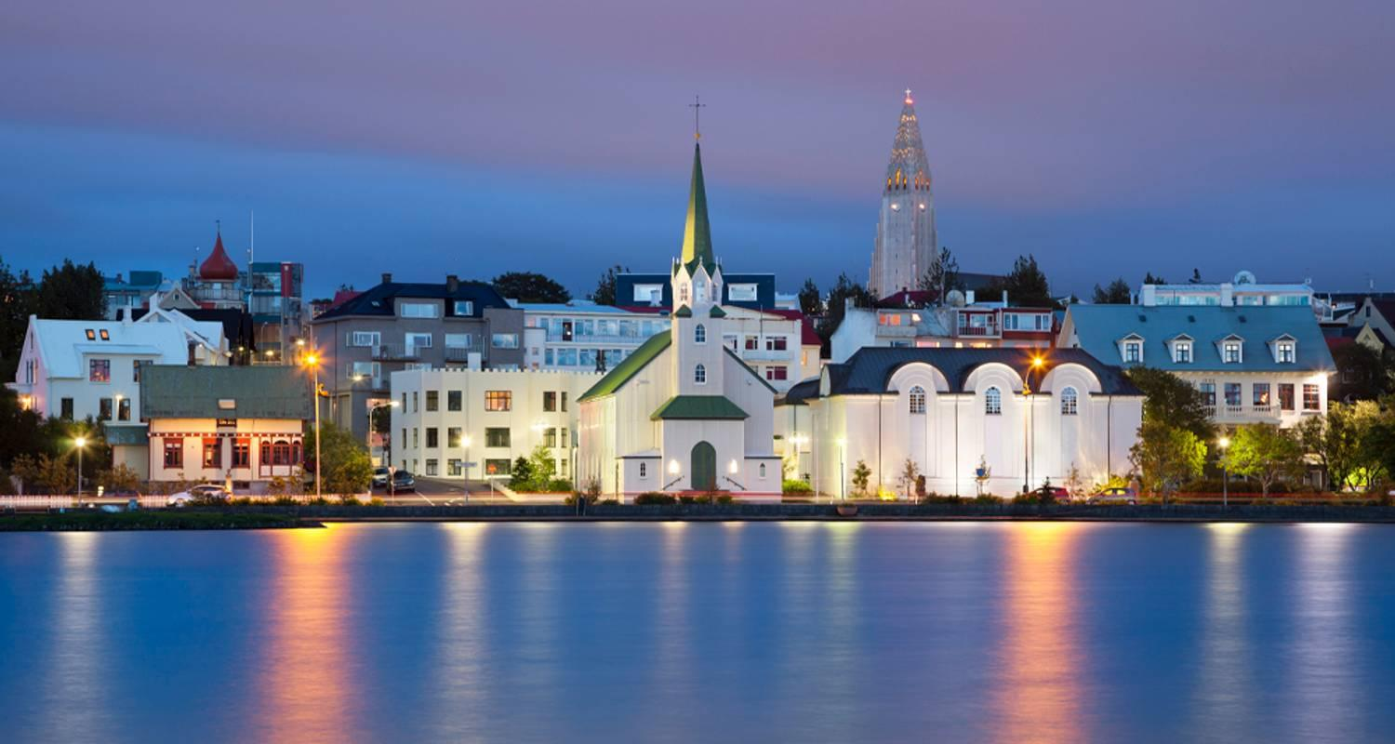

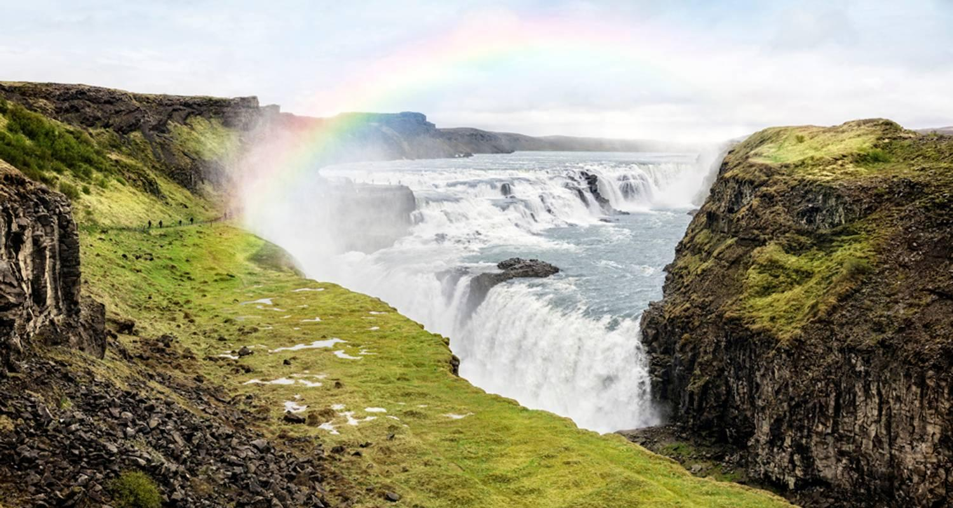

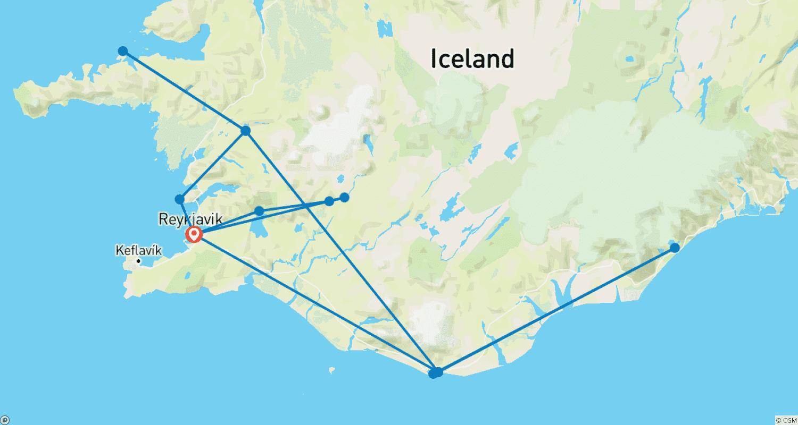

Tour ID: 270233  
Tour Name: Iceland & Copenhagen Deluxe

Tour destinations: ['Keflavik', 'Reykjavik', 'Thingvellir National Park', 'Copenhagen']

Tour destinations images:

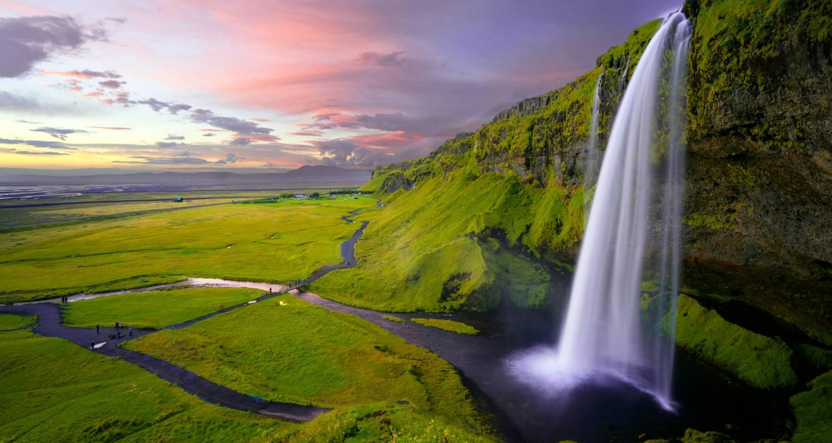

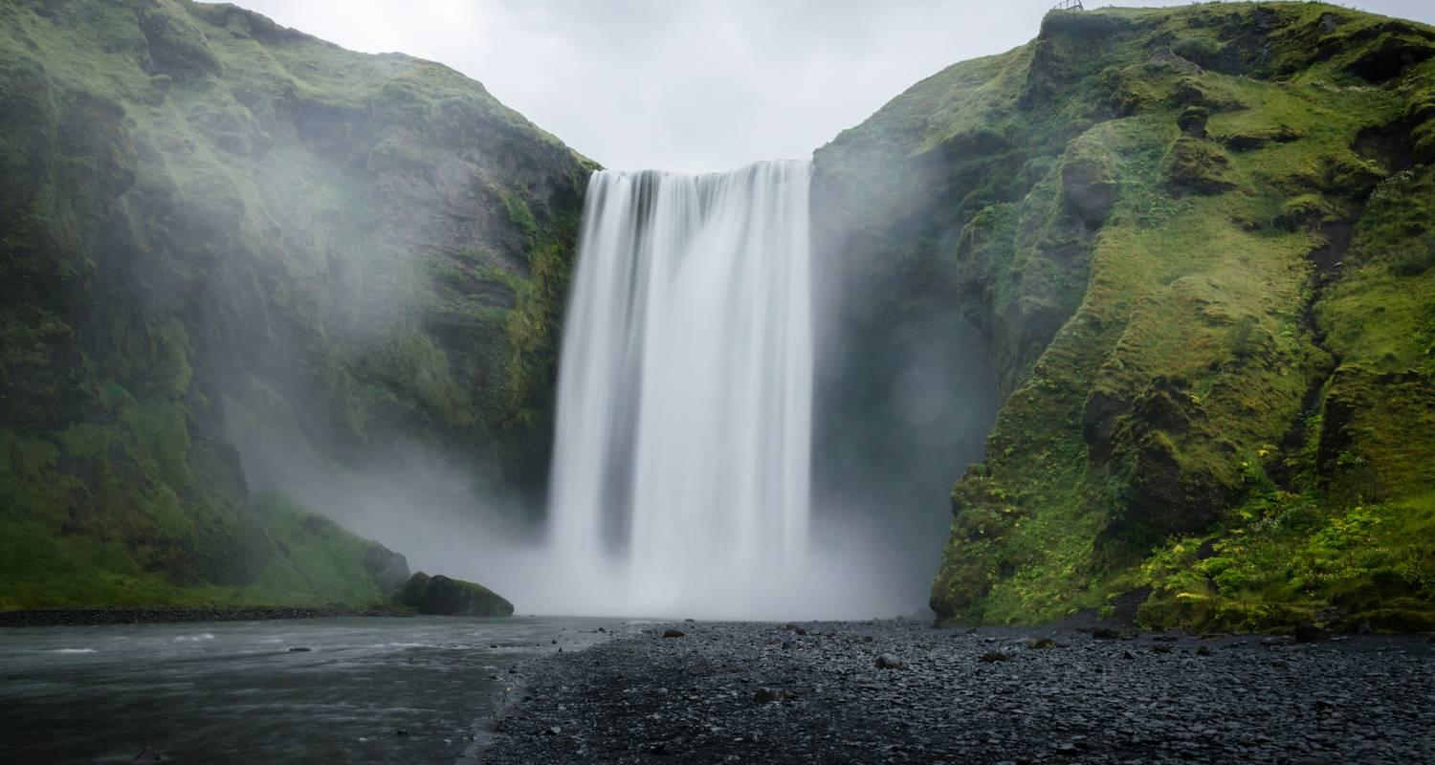

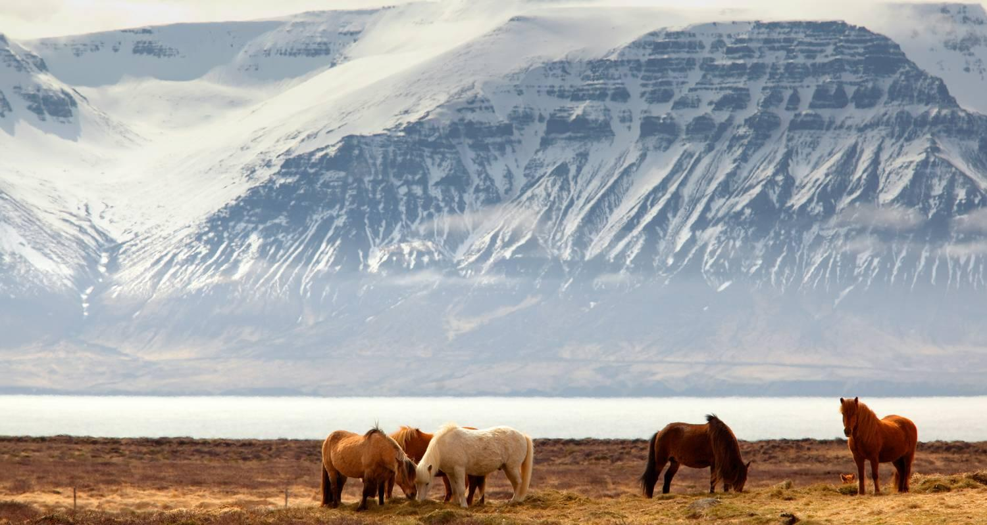

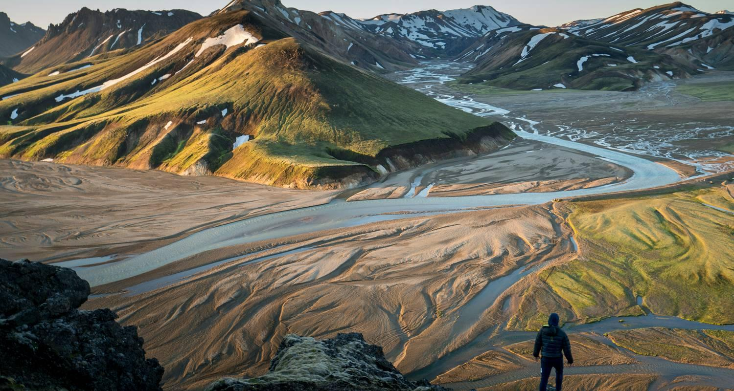

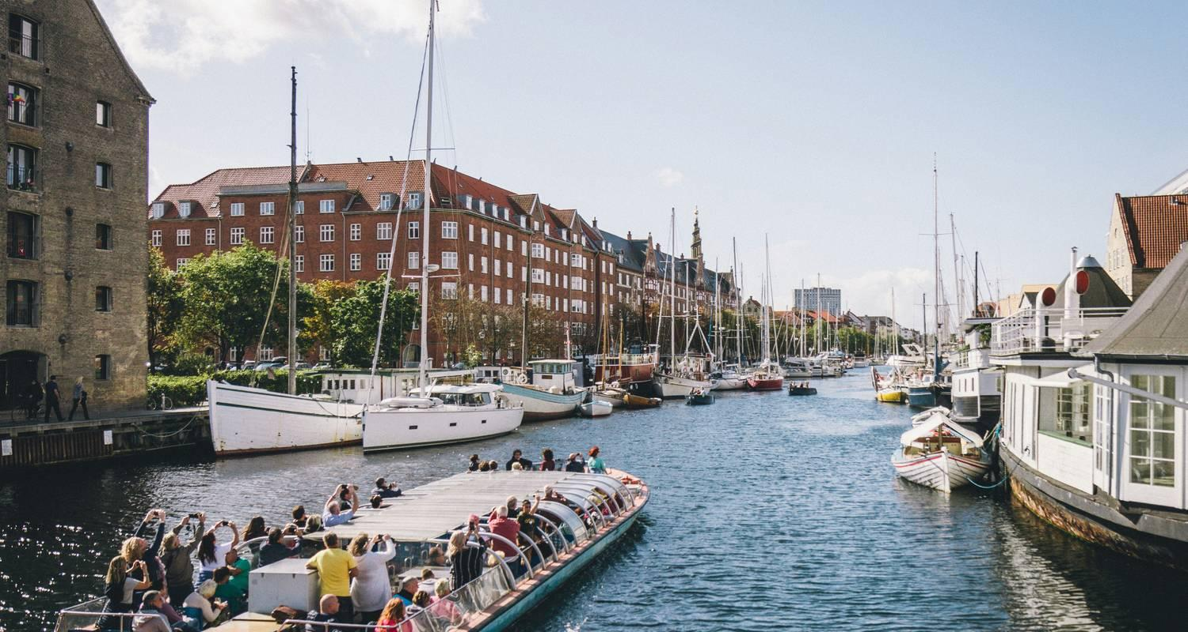

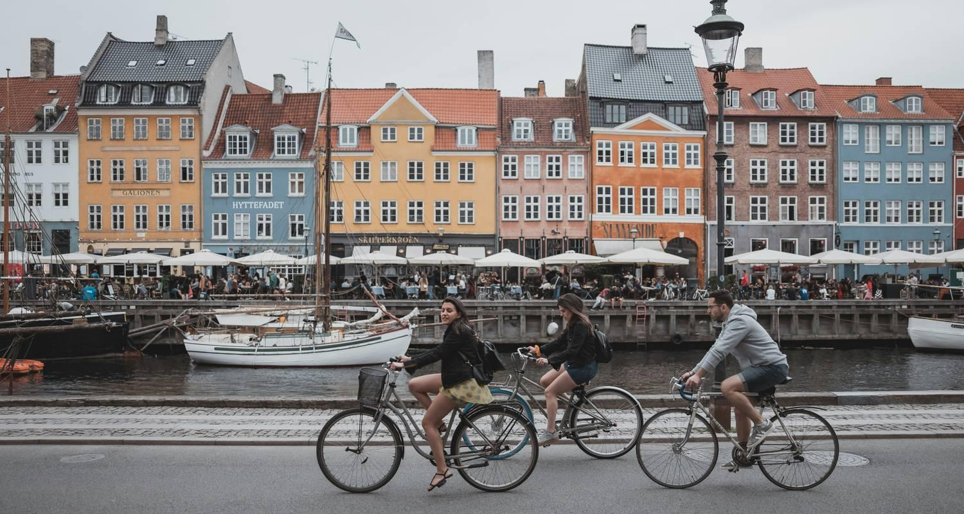

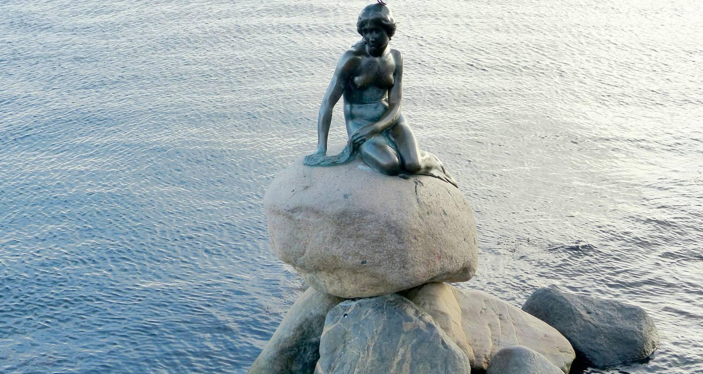

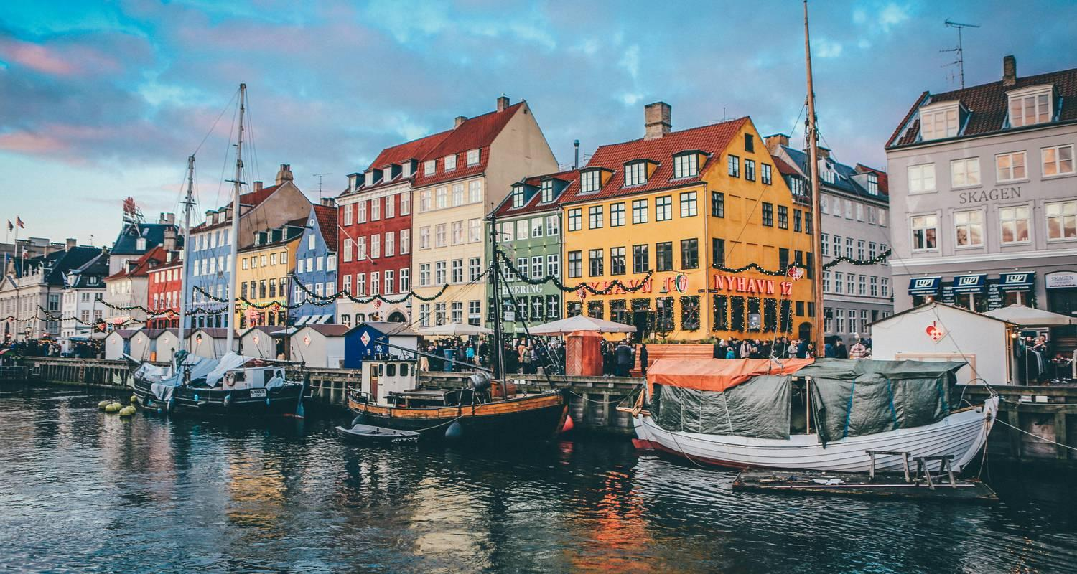

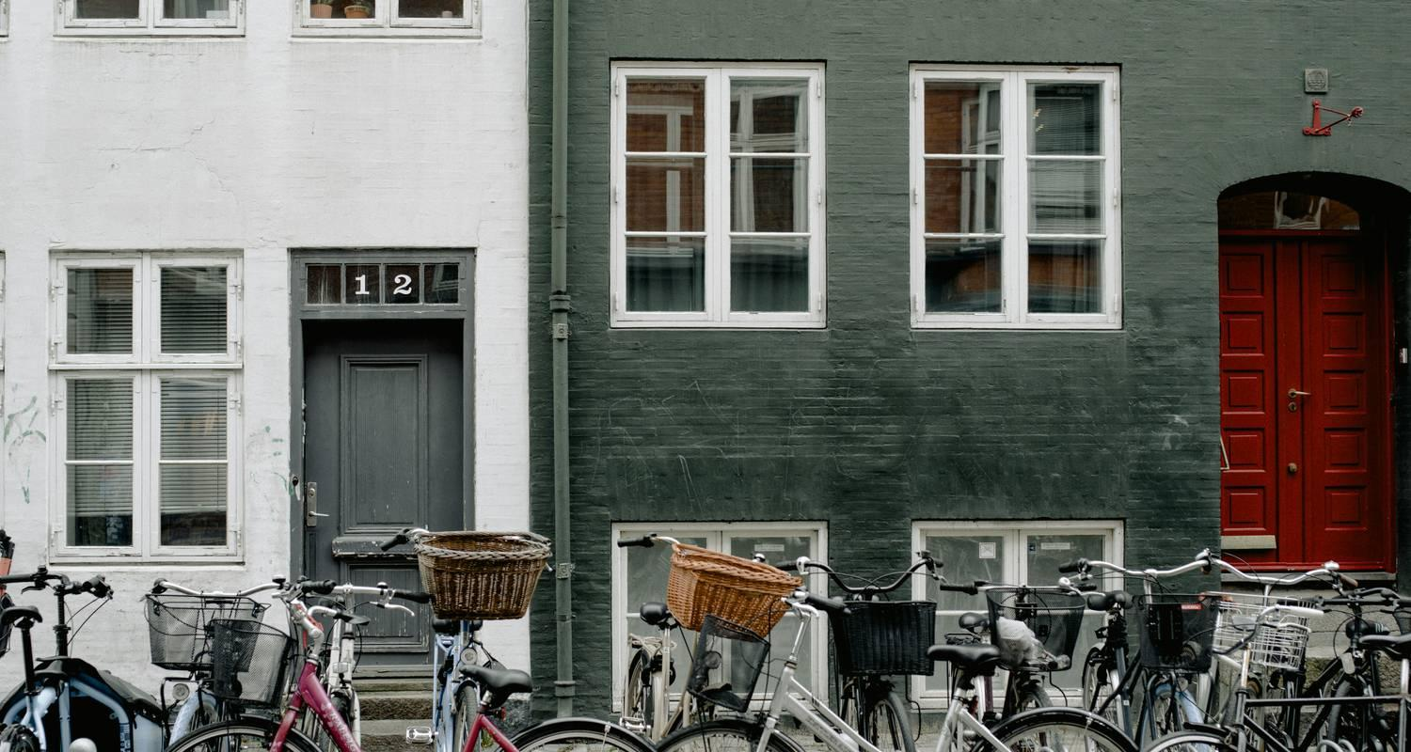

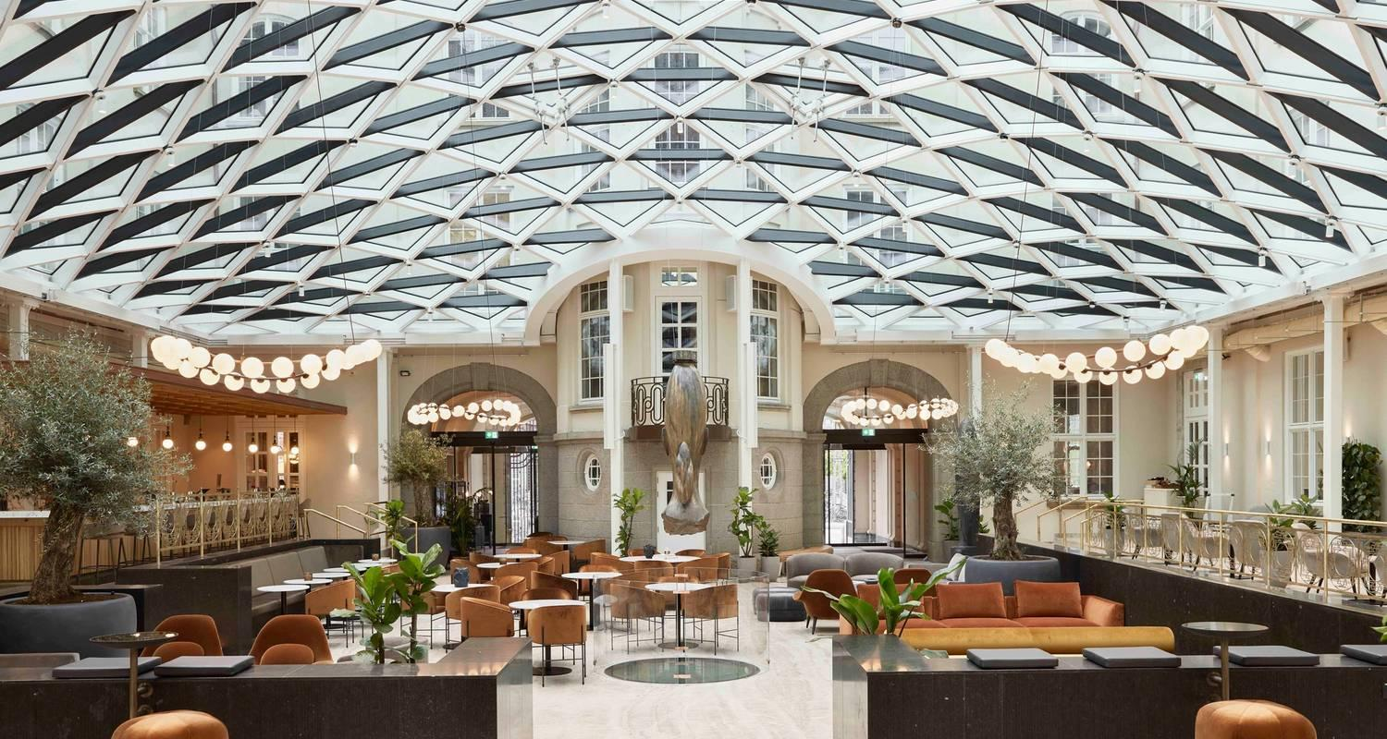

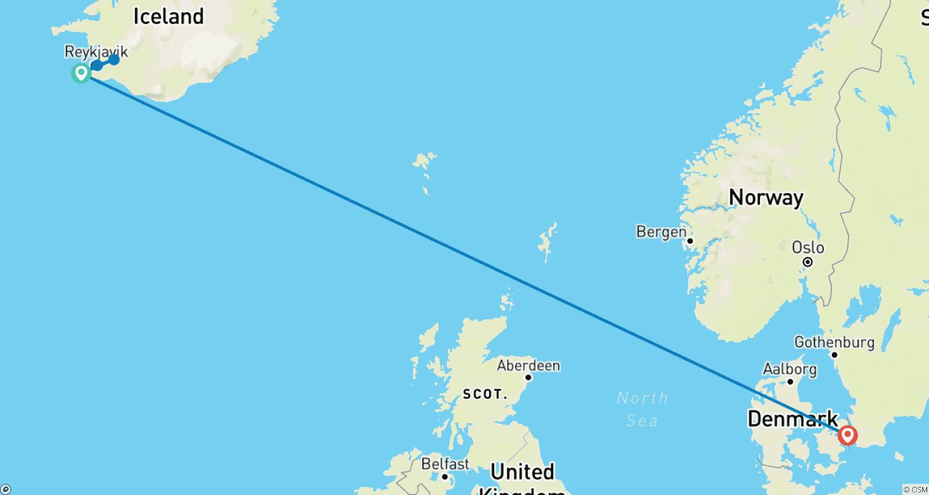

Tour ID: 270624  
Tour Name: Icelandic Adventure (2025)

Tour destinations: ['Reykjavik', 'Thingvellir National Park', 'Husavik', 'Godafoss', 'Akureyri', 'Laugarbakki', 'Snæfellsnes', 'Borgarnes', 'Húsafell']

Tour destinations images:

